Final Report

Faculty Sponsor:

Suneuy Kim - San Jose State University Professor

San Jose State University - College of Engineering

Principal Investigators:

Diego Cruz

Jared Park

Andrew Tedijanto

Shuti Wang

Team CPTW

**3. Database schema in the form of SQL CREATE TABLE. Specify key constraints and foreign key constraints in the schema.**

DROP DATABASE IF EXISTS PLUGINS;

CREATE DATABASE PLUGINS;

USE PLUGINS;

DROP TABLE IF EXISTS Plugins;

CREATE TABLE Plugins(

plugin VARCHAR(50), # plugin uses as join attributes(name) in generator and fx table

developer VARCHAR(30),

type VARCHAR(20), # fx or generator

PRIMARY KEY(plugin)

);

DROP TABLE IF EXISTS Generator;

CREATE TABLE Generator(

name VARCHAR(50) PRIMARY KEY, # name of the plugin

format VARCHAR(10),

subtype VARCHAR(50),

isFree BOOLEAN DEFAULT FALSE,

hasLicense BOOLEAN DEFAULT FALSE,

lastUpdate timestamp not null on update current_timestamp # 0000-00-00 00:00:00

);

DROP TABLE IF EXISTS Fx;

CREATE TABLE Fx(

name VARCHAR(50) PRIMARY KEY, # name of the plugin

format VARCHAR(10),

subtype VARCHAR(50),

isFree BOOLEAN DEFAULT FALSE,

hasLicense BOOLEAN DEFAULT FALSE,

lastUpdate timestamp not null on update current_timestamp

);

DROP TABLE IF EXISTS User;

CREATE TABLE User(

uID INT AUTO_INCREMENT,

name VARCHAR(30),

age INT,

downLoaded INT,

PRIMARY KEY(uID)

);

DROP TABLE IF EXISTS Downloaded;

CREATE TABLE Downloaded(

uID INT,

plugin VARCHAR(50),

downloadDate timestamp not null on update current_timestamp,

PRIMARY KEY(uID, plugin, downloadDate),

FOREIGN KEY(uID) references User (uID) on delete cascade,

FOREIGN KEY(plugin) references Plugins (plugin) on delete cascade

);

DROP TABLE IF EXISTS Archive;

CREATE TABLE Archive(

name VARCHAR(50) primary key, # name of the plugin

format VARCHAR(10),

developer VARCHAR(30),

type VARCHAR(20), # fx or generator

subtype VARCHAR(50),

isFree BOOLEAN DEFAULT FALSE,

hasLicense BOOLEAN DEFAULT FALSE,

lastUpdate timestamp not null on update current_timestamp,

uID INT,

downloadDate timestamp on update current_timestamp

);

4. **Indicate if your team used a public data set or not. If a public data set is used, specify its URL.**

Our project is a representation of plugin management for audio processing software commonly used in audio engineering applications and music production. The data set is inspired by the current software inside of the King Library 4th Floor Sound Studio managed by Student Computing Services as well as the software inside of the personal workstation of Diego Cruz. The data set structure is partially inspired by the plugin databases that exist for Digital Audio Workstation softwares such as Image-Line FL Studio and Cockos REAPER. The group sought to improve upon these already-established plugin databases by introducing new attributes as well as introducing a modified structure expressed through tables.

**5. Descriptions to show relation schemas are in BCNF or in 3NF.**

Step 1: start with all attributes

R(plugin, format, developer, type, subtype, isFree, hasLicense, lastUpdate, uID, name, age, downloaded, downloadDate,)

plugin -> developer, type

plugin(name)-> format, subtype, isFree, hasLicense, lastUpdate

uID -> name, age, downloaded

uID, plugin, downloadDate -> uID, plugin, downloadDate

{plugin}+ : {plugin, developer, type, format, subtype, isFree, hasLicense, lastUpdate} is not a super key, BCNF violation.

{uID}+: {uID, name, age, downloaded} is not a super key, BCNF violation

{uID, plugins, downloadDate}+ : {uID, name, age, downloaded, plugins, downloadDate} is not a super key, BCNF violation.

Step 2: decompose

Decompose 1:

R(plugin, developer, type, format, subtype, isFree, hasLicense, lastUpdate)

plugin -> developer, type

plugin(name)-> format, subtype, isFree, hasLicense, lastUpdate

{plugin}+ : {plugin, developer, type, format, subtype, isFree, hasLicense, lastUpdate} is a super key, no BCNF violation.

Since we have 2 types, we decided to further decompose into 2 tables based on the type (Fx, Generator)

Each type will have it attributes: (plugin(name)-> format, subtype, isFree, hasLicense, lastUpdate)

Decompose 2:

R(uID, name, age, downloaded, plugin, downloadDate, downloadDate)

uID -> name, age, downloaded

uID, plugin, downloadDate -> uID, plugin, downloadDate

{uID}+: {uID, name, age, downloaded} is not a super key, BCNF violation

{uID, plugins, downloadDate}+ : {uID, plugins, downloadDate, name, age, downloaded} is super key, no BCNF violation.

Decompose 3

R(uID, name, age, downloaded}

uID -> name, age, downloaded

{uID}+: {uID, name, age, downloaded} is a super key, no BCNF violation

Step 3 all the tables we have:

Plugins(plugin, developer, type)

Generator(name, format, subtype, isFree, hasLicense, lastUpdate)

Fx(name, format, subtype, isFree, hasLicense, lastUpdate)

User(uID, name, age, downloaded)

Downloaded(uID, plugin, downloadDate)

Archive table will have attributes :Archive(plugin(name), format, developer, type, subtype, isFree, hasLicense, lastUpdate, uID, downloaDate) with plugin(name) as the primary key.

**6. Screenshots of all relations after populating initial data. Label each relation clearly.**

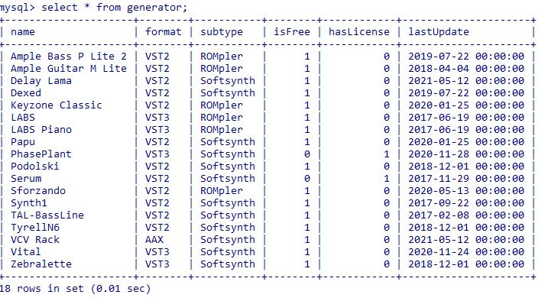

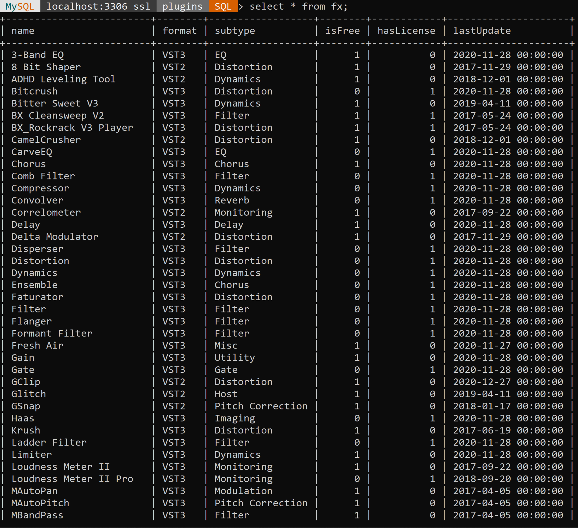

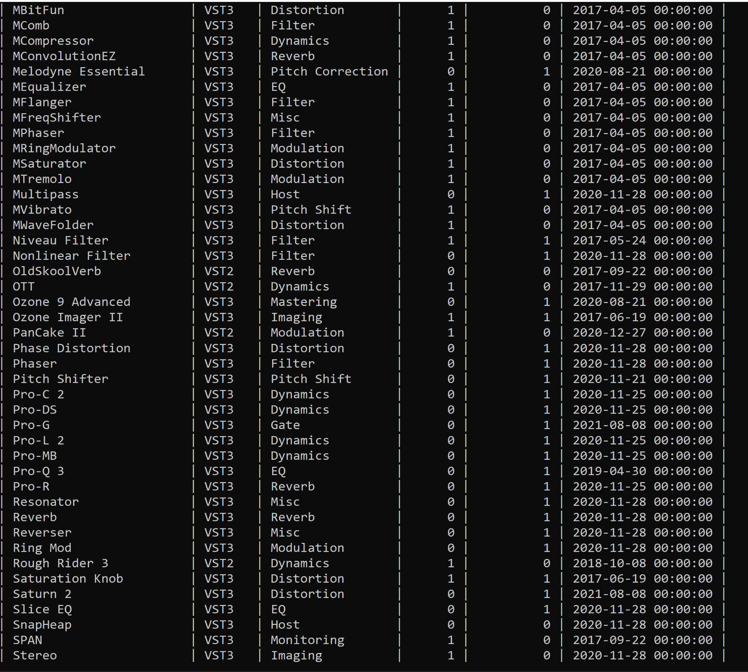

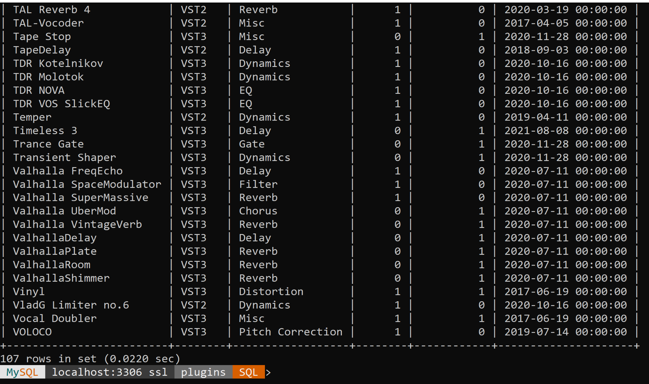

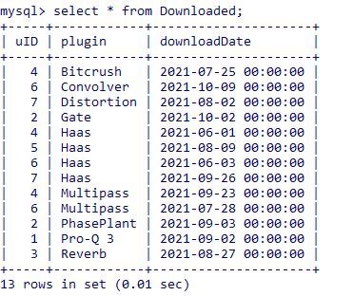

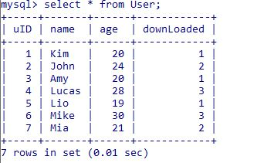

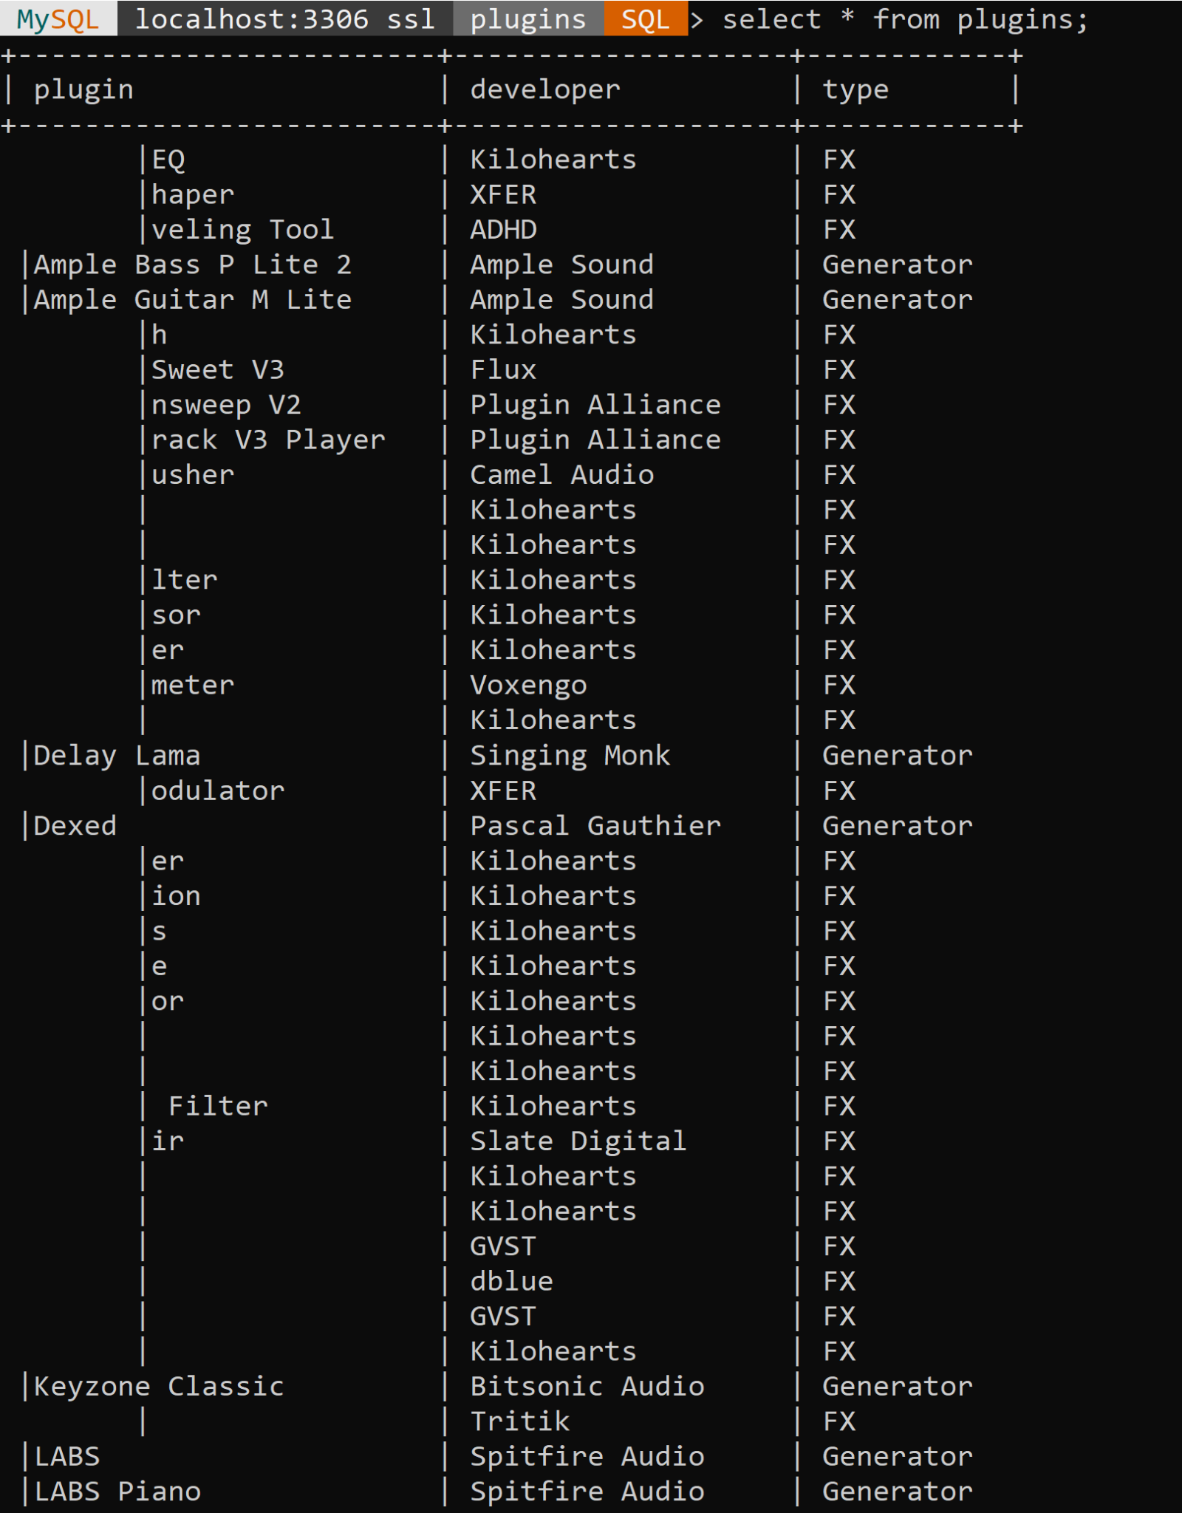

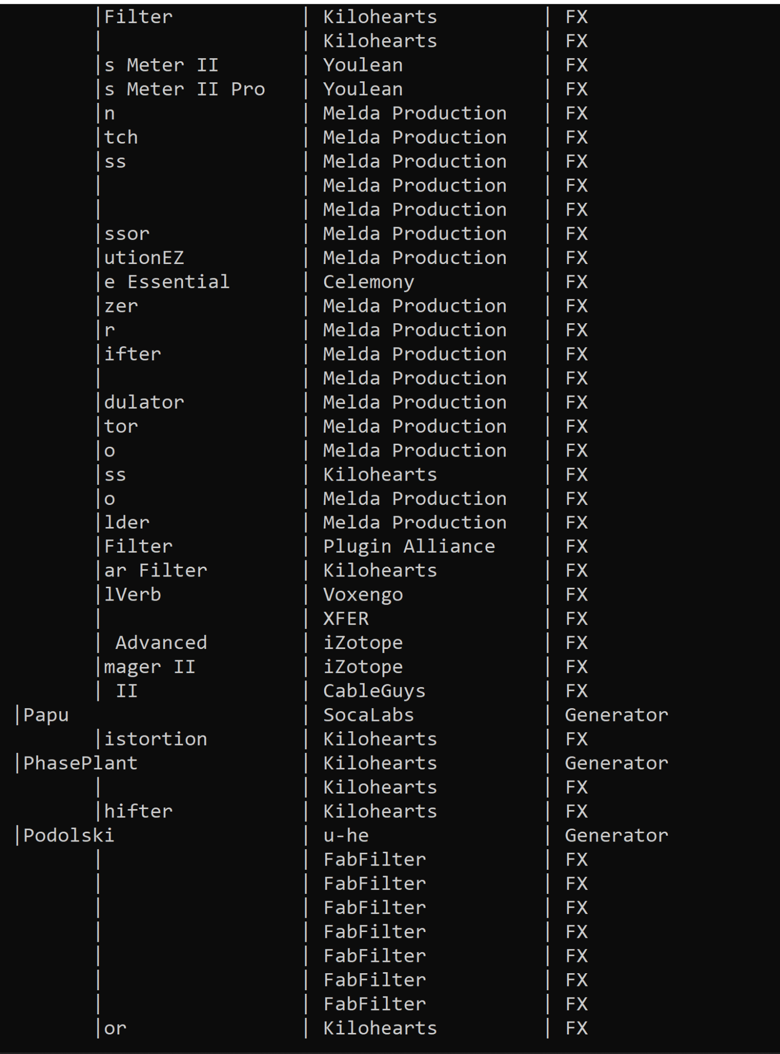

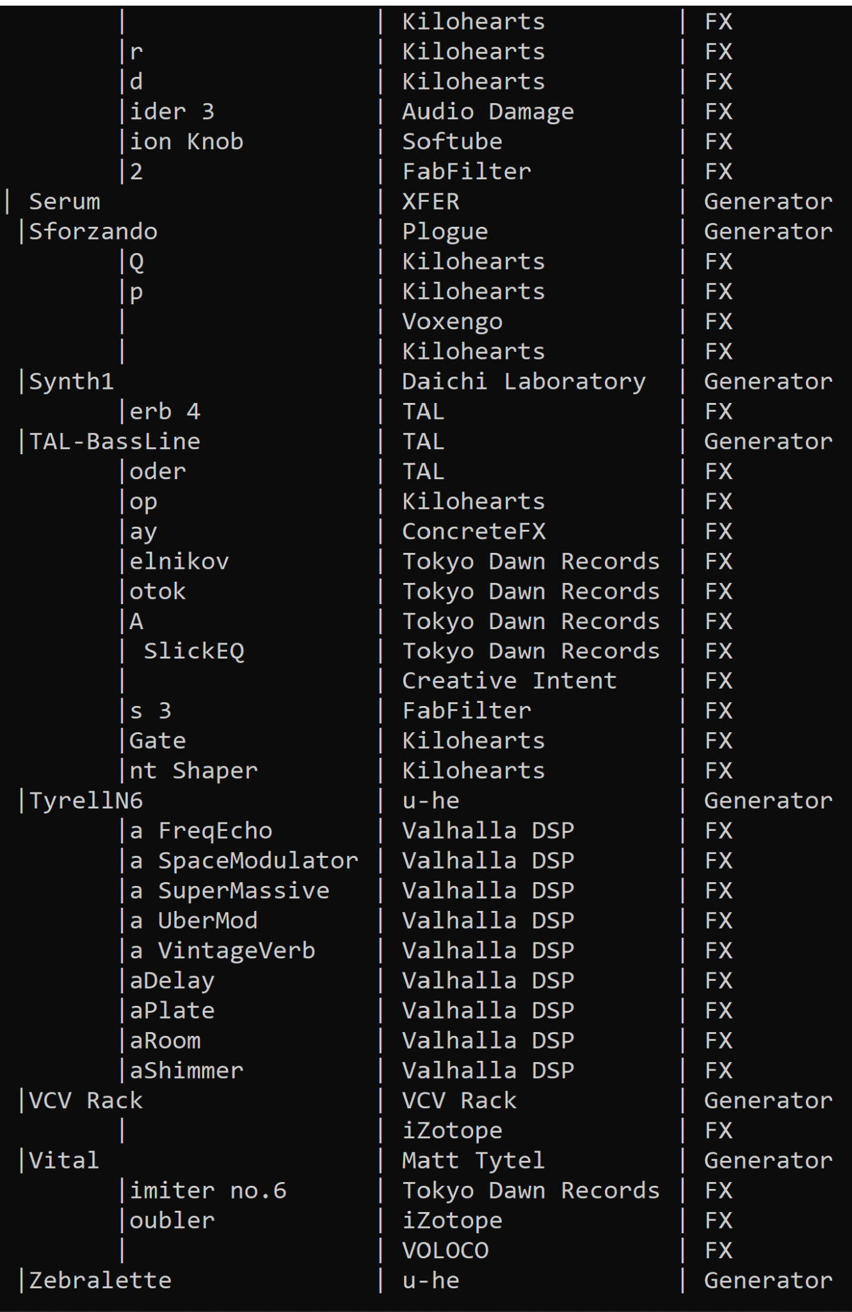



**7. List of at least 15 distinct functions excluding functions done by DBA. List each function in English and include all associated SQL statements, triggers, and stored procedures to support that particular function.**

* List all SQL select statements: 9 select queries

// select 1

// this select query will find developers who make both fx plugins and generator plugins and find // total plugins each of these selected developers create.

select developer, **count**(developer) as numOfPlugins from plugins old

where type !=any (select type from plugins where developer = **old.developer**)

**group by** (developer);

// select 2

// this select query will find the type of plugin that is downloaded the most by users

select type from plugins **join** (

select plugin, count from (

select plugin, **count**(plugin) as count from downloaded group by plugin) as d1

where d1.count >= all(

select **count**(plugin) from downloaded **group by** plugin))d2

where d2.plugin = plugins.plugin;

// select 3

// this query will find users who downloaded both fx and generator plugins

select name from user where uid = (select uID from

(select uID, plugin from downloaded natural **join** plugins

where plugin != all (select name from fx))t1 **join**

(select uID, plugin from downloaded natural join plugins

where plugin = any (select name from fx))t2 **using**(uID));

//select 4

//select the names of the plugins that have been downloaded from Fx and Generator after the //year 2020

select distinct generator.name from generator

**left outer join** downloaded on generator.name = downloaded.plugin

where generator.lastUpdate > '2019-12-31' and downloaded.downloadDate > '2019-12-31'

union all

select distinct fx.name from fx

**right outer join** downloaded on fx.name = downloaded.plugin

where fx.lastUpdate > '2019-12-31' and downloaded.downloadDate > '2019-12-31';

//select 5

//select number of generator plugins and fx plugins in VST3 format

select count(distinct generator.name) as genCount, count(distinct fx.name) as fxCount

from generator, FX

where generator.format = 'VST3' and fx.format = 'VST3';

//select 6

//select average number of plugins in fx table that are free

select avg(stcounts.ct)

from(

select count(subtype) as ct

from fx

where fx.isFree = 1

**group by** subtype

**having** count(subtype) > 1

) as stcounts;

//select 7

//select all users that have the same number of downloads

select distinct u1.name as User1, u2.name as User2

from User u1, User u2

where u1.name < u2.name and u1.downLoaded = u2.downLoaded

group by u1.uID;

//select 8 find developers made only one type of plugins and not the other and the total the //plugins that developer made

select developer, type, **count**(developer) as numOfPlugins from plugins where developer **!= any** (select developer from plugins old where type **!= any** (

select type from plugins where **old**.developer = developer) **group by** developer) **group by** developer;

// select 9 : select user whose download is not free but has license

select user.name from (select uid from (select * from downloaded **left outer join** generator on plugin = name **union** select * from downloaded **left outer join** fx on plugin = name) t where t.name is not null and isFree = 0 and hasLicense = 1 **group by**(uid)) s natural join user;

* List all SQL update statements: 2 update queries

// update 1: update the plugin ‘Delay Lama’ with the current time.

update generator set lastUpdate = now() where name = 'Delay Lama';

// update 2 : update generator by inverting the isFree variable for plugins with the subtype ‘ROMpler’

update generator set isFree = not isFree where subtype = ‘ROMpler’;

* List all SQL delete statements: 2 delete queries

// delete 1 : work with trigger 2

/// delete the uid =7, and plugin = ‘Haas’ and downloadDate=’2021-09-26’ will delete the record // from the downloaded table as well as update the user table for the downloaded times for uid 7

// in this case if uid has downloaded 2 times, then after deletion from downloaded table, his/her

// user table will be updated to 1 times (work with trigger 2)

delete from downloaded where uid = 7 and plugin ='Haas' and downloadDate='2021-09-26';

// delete 2 // expiration after 4 months

//delete plugins that have not been updated in 4 months

delete from fx

where NOW() > DATE_ADD(fx.lastUpdate, INTERVAL 4 MONTH);

* List all SQL insert statements: 2 insert queries

// insert 1: work with trigger 1

// for insert into downloaded table where user download new plugins at current time

insert into downloaded values(1, 'Haas', now());

// insert 2: insert a new user

insert into user(name, age, downloaded) values('Anna', 20, 0);

* List all SQL triggers: 2 triggers

// trigger 1:

// create trigger validateUserForDownload before insert into downloaded table, need to check //if user is an existing user, and will add 1 to total download times for that user in the user table.

delimiter //

drop trigger if exists validateUserForDownload;

create trigger validateUserForDownload

before insert on downloaded

for each row

if new.uID in (select uID from user)

then update User set downLoaded = downLoaded +1 where uID = new.uID;

end if;//

delimiter ;

// trigger 2:

// delete record from downloaded table, the user table downloaded plugin’s time will be reduced // as well, this trigger will not check delete record input for validation. So it is allow delete //multiple record, as long as the value in the where clause exist in the downloaded table

delimiter //

drop trigger if exists deleteDownloadRecord;

create trigger deleteDownloadRecord

before delete on downloaded

for each row

begin

update User set downloaded = downloaded -1 where uid = old.uid;

end;//

delimiter ;

* List all SQL stored procedures: 1 stored procedures

// stored procedure table archive will store old plugins that its lastUpdate was 2020 and earlier. //this procedure will first insert into archive using data from plugins join fx and plugins join //generator using common attribute plugin name and the given parameter ‘last_update’ . Then //delete old plugs info from plugins, fx and generator table using common attributes and given //parameters. Archive table also include user who has downloaded that plugins

drop procedure if exists archive;

delimiter //

create procedure archive(IN last_update timestamp)

begin

insert into archive (name, format, developer, type, subtype, isFree, hasLicense, lastUpdate, uID, downloadDate) select name, format, developer, type, subtype, isFree, hasLicense, lastUpdate, uID, downloadDate from plugins join fx on fx.name = plugins.plugin and fx.lastUpdate < last_update left outer join downloaded on downloaded.plugin = plugins.plugin;

insert into archive (name, format, developer, type, subtype, isFree, hasLicense, lastUpdate, uID, downloadDate) select name, format, developer, type, subtype, isFree, hasLicense, lastUpdate, uID, downloadDate from plugins join generator on generator.name = plugins.plugin and generator.lastUpdate < last_update left outer join downloaded on downloaded.plugin = plugins.plugin;

delete from plugins where plugins.plugin in (select name from fx where lastUpdate < last_update);

delete from plugins where plugins.plugin in (select name from generator where lastUpdate < last_update);

delete from fx where lastUpdate < last_update;

delete from generator where lastUpdate < last_update;

end //

delimiter ;

call archive('2020-01-01');

**8. The following requirements are for me to check there are at least 5 significantly different queries involving different relations and attributes.**

* + **Please highlight in bold the five siginificantly different types of SQL (one co-related subquery, group by and having, aggregation, outer join, and mathematical set operation)**
* List all SQL select statements: 9 select queries

// select 1

// this select query will find developers who make both fx plugins and generator plugins and find // total plugins each of these selected developers create.

select developer, **count**(developer) as numOfPlugins from plugins old

where type !=any (select type from plugins where developer = **old.developer**)

**group by** (developer);

// select 2

// this select query will find the type of plugin that is downloaded the most by users

select type from plugins **join** (

select plugin, count from (

select plugin, **count**(plugin) as count from downloaded group by plugin) as d1

where d1.count >= all (

select **count**(plugin) from downloaded **group by** plugin))d2

where d2.plugin = plugins.plugin;

// select 3

// this query will find users who downloaded both fx and generator plugins

select name from user where uid = (select uID from

(select uID, plugin from downloaded natural **join** plugins

where plugin != all (select name from fx)) t1 **join**

(select uID, plugin from downloaded natural join plugins

where plugin = any (select name from fx)) t2 **using**(uID));

//select 4

//select the names of the plugins that have been downloaded from Fx and Generator after the //year 2020

select distinct generator.name from generator

**left outer join** downloaded on generator.name = downloaded.plugin

where generator.lastUpdate > '2019-12-31' and downloaded.downloadDate > '2019-12-31'

union all

select distinct fx.name from fx

**right outer join** downloaded on fx.name = downloaded.plugin

where fx.lastUpdate > '2019-12-31' and downloaded.downloadDate > '2019-12-31';

//select 5

//select number of generator plugins and fx plugins in VST3 format

select count(distinct generator.name) as genCount, count(distinct fx.name) as fxCount

from generator, FX

where generator.format = 'VST3' and fx.format = 'VST3';

//select 6

//select average number of plugins in fx table that are free

select avg(stcounts.ct)

from(

select count(subtype) as ct

from fx

where fx.isFree = 1

**group by** subtype

**having** count(subtype) > 1

) as stcounts;

//select 7

//select all users that have the same number of downloads

select distinct u1.name as User1, u2.name as User2

from User u1, User u2

where u1.name < u2.name and u1.downLoaded = u2.downLoaded

group by u1.uID;

//select 8 find developers made only one type of plugins and not the other and the total the //plugins that developer made

select developer, type, **count**(developer) as numOfPlugins from plugins where developer **!= any** (select developer from plugins old where type **!= any** (

select type from plugins where **old**.developer = developer) **group by** developer) **group by** developer;

// select 9 : select user whose download is not free but has license

select user.name from (select uid from (select * from downloaded **left outer join** generator on plugin = name **union** select * from downloaded **left outer join** fx on plugin = name) t where t.name is not null and isFree = 0 and hasLicense = 1 **group by**(uid)) s natural join user;

* List all SQL update statements: 2 update queries

// update 1: update the plugin ‘Delay Lama’ with the current time.

update generator set lastUpdate = now() where name = 'Delay Lama';

// update 2 : update generator by inverting the isFree variable for plugins with the subtype ‘ROMpler’

update generator

set isFree = not isFree

where subtype = ‘ROMpler’;

* List all SQL delete statements: 2 delete queries

// delete 1 : work with trigger 2

/// delete the uid =7, and plugin = ‘Haas’ and downloadDate=’2021-09-26’ will delete the record // from the downloaded table as well as update the user table for the downloaded times for uid 7

delete from downloaded where uid = 7 and plugin ='Haas' and downloadDate='2021-09-26';

// delete 2 // expiration after 4 months

//delete plugins that have not been updated in 4 months

delete from fx

where NOW() > DATE_ADD(fx.lastUpdate, INTERVAL 4 MONTH);

* List all SQL insert statements: 2 insert queries

// insert 1: work with trigger 1

// for insert into downloaded table where user download new plugins at current time

insert into downloaded values(1, 'Haas', now());

// insert 2: insert a new user

insert into user(name, age, downloaded) values('Anna', 20, 0);

* List all SQL triggers: 2 triggers

// trigger 1:

// create trigger validateUserForDownload before insert into downloaded table, need to check //if user is an existing user, and will add 1 to total download times for that user in the user table.

delimiter //

drop trigger if exists validateUserForDownload;

create trigger validateUserForDownload

before insert on downloaded

for each row

if new.uID in (select uID from user)

then update User set downLoaded = downLoaded +1 where uID = new.uID;

end if;//

delimiter ;

// trigger 2:

// delete record from downloaded table, the user table downloaded plugin’s time will be reduced // as well, this trigger will not check delete record input for validation. So it is allow delete //multiple record, as long as the value in the where clause exist in the downloaded table

delimiter //

drop trigger if exists deleteDownloadRecord;

create trigger deleteDownloadRecord

before delete on downloaded

for each row

begin

update User set downloaded = downloaded -1 where uid = old.uid;

end;//

delimiter ;

* List all SQL stored procedures: 1 stored procedures

// stored procedure table archive will store old plugins that its lastUpdate was 2020 and earlier. //this procedure will first insert into archive using data from plugins join fx and plugins join //generator using common attribute plugin name and the given parameter ‘last_update’ . Then //delete old plugs info from plugins, fx and generator table using common attributes and given //parameters. Archive table also include user who has downloaded that plugins

drop procedure if exists archive;

delimiter //

create procedure archive(IN last_update timestamp)

begin

insert into archive (name, format, developer, type, subtype, isFree, hasLicense, lastUpdate, uID, downloadDate) select name, format, developer, type, subtype, isFree, hasLicense, lastUpdate, uID, downloadDate from plugins join fx on fx.name = plugins.plugin and fx.lastUpdate < last_update left outer join downloaded on downloaded.plugin = plugins.plugin;

insert into archive (name, format, developer, type, subtype, isFree, hasLicense, lastUpdate, uID, downloadDate) select name, format, developer, type, subtype, isFree, hasLicense, lastUpdate, uID, downloadDate from plugins join generator on generator.name = plugins.plugin and generator.lastUpdate < last_update left outer join downloaded on downloaded.plugin = plugins.plugin;

delete from plugins where plugins.plugin in (select name from fx where lastUpdate < last_update);

delete from plugins where plugins.plugin in (select name from generator where lastUpdate < last_update);

delete from fx where lastUpdate < last_update;

delete from generator where lastUpdate < last_update;

end //

delimiter ;

call archive('2020-01-01');

**9. Screenshots to demonstrate the following functionality. Label each screenshot clearly.**

* + each 15 functions
  + archiving
  + key constraint and foreign key constraint violations

// select 1

// this select query will find developers who make both fx plugins and generator plugins and find // total plugins each of these selected developers create.

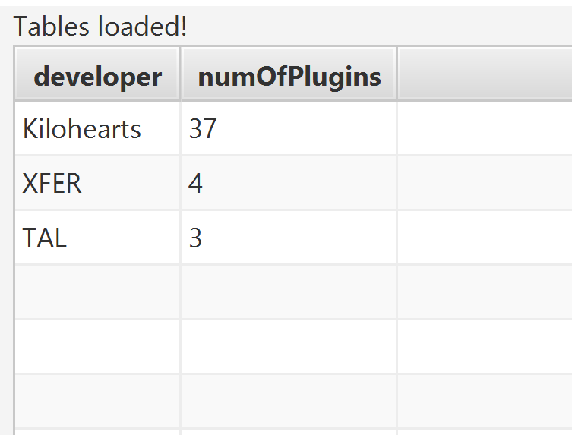

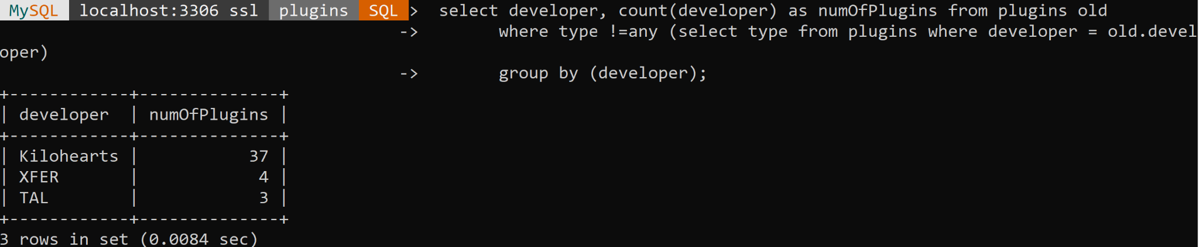

// select 2

// this select query will find the type of plugin that is downloaded the most by users

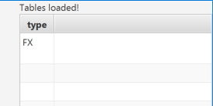

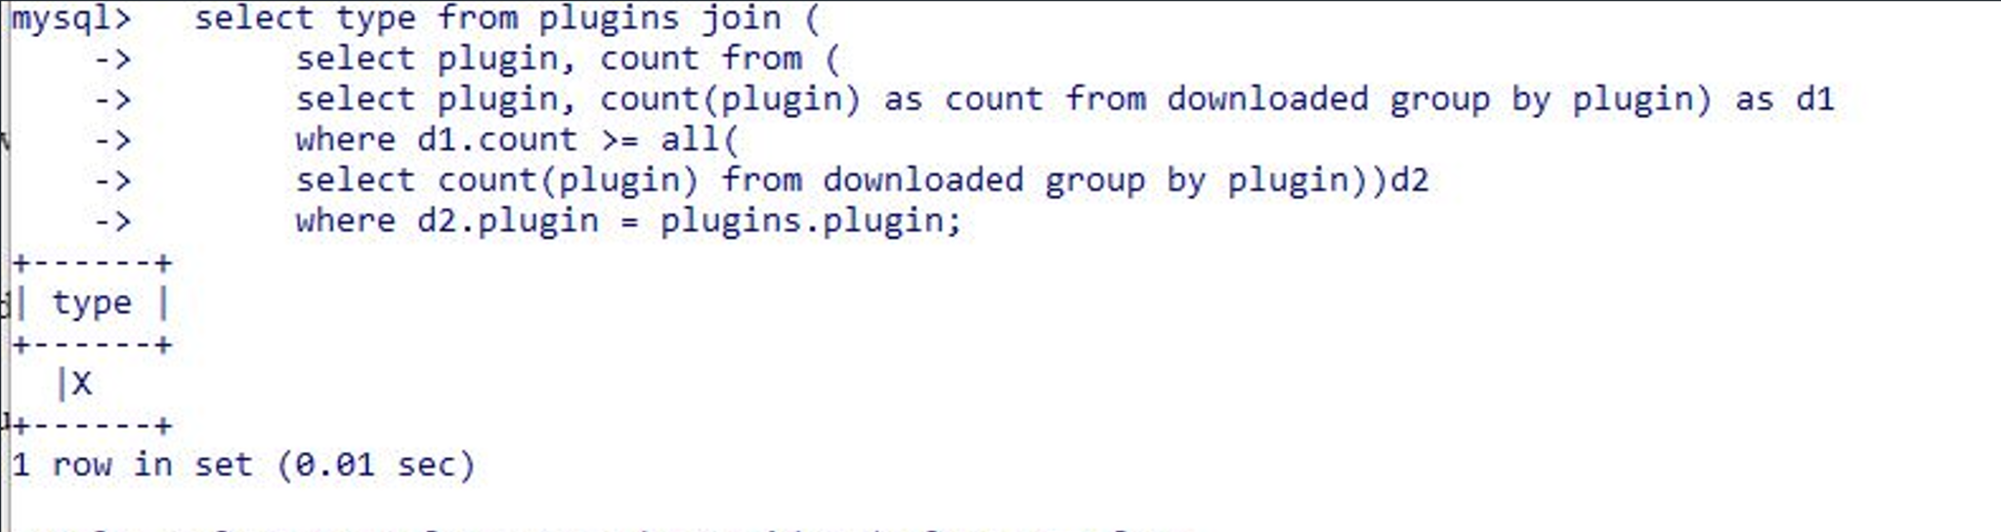

// select 3

// this query will find users who downloaded both fx and generator plugins

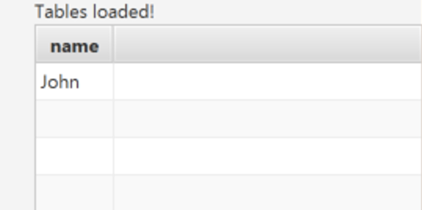

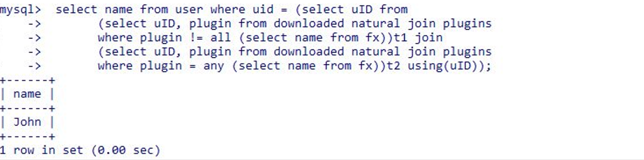

//select 4

//select the names of the plugins that have been downloaded from Fx and Generator after the //year 2020

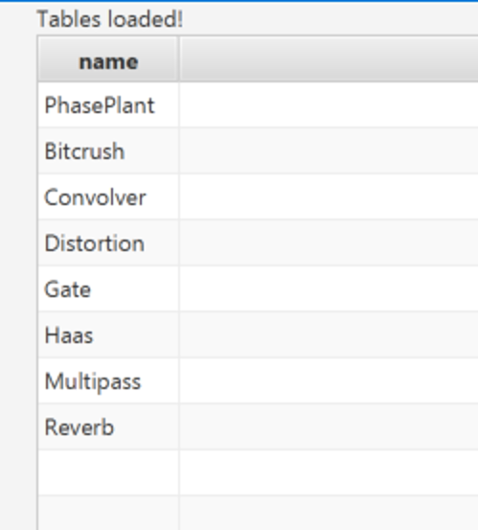

//select 5

//select number of generator plugins and fx plugins in VST3 format

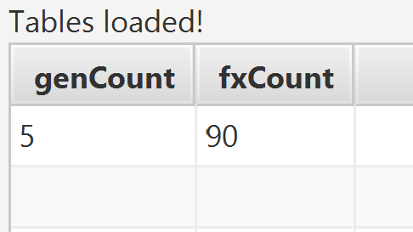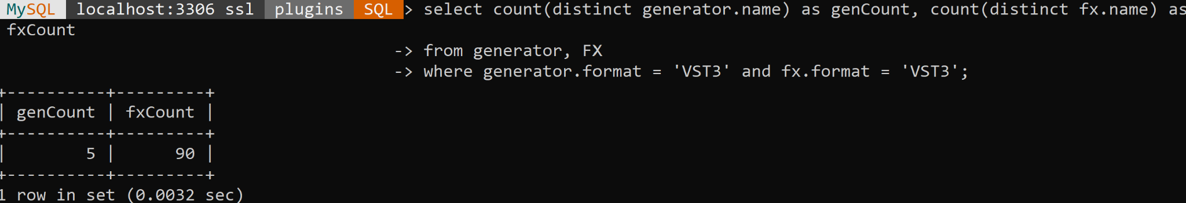

//select 6

//select average number of plugins in fx table that are free

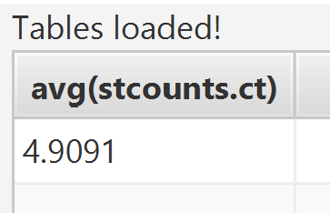

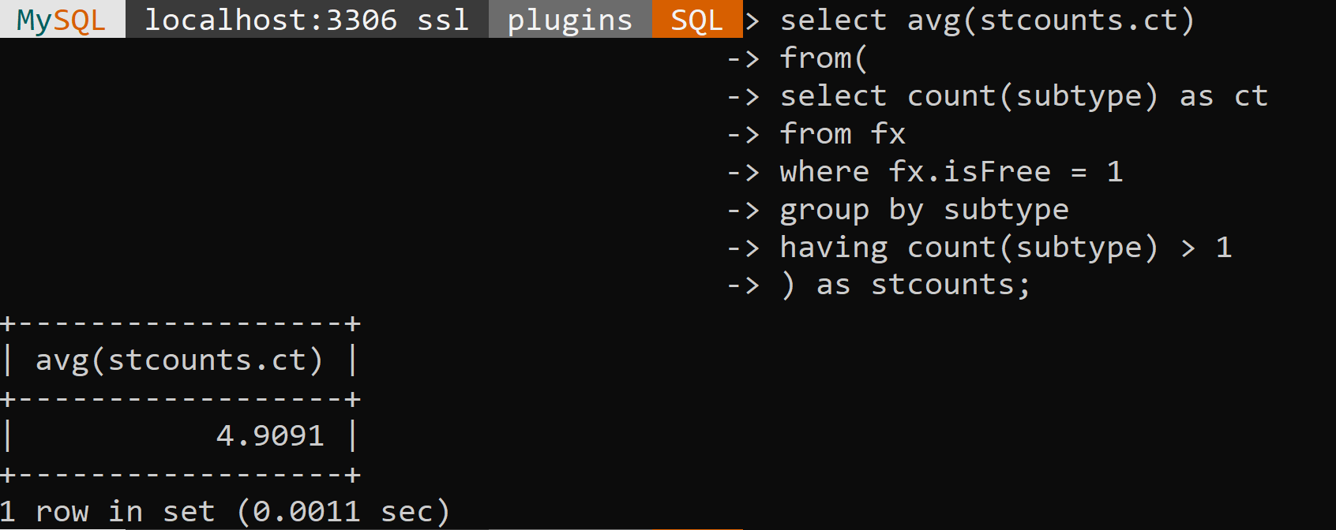

//select 7

//select all users that have the same number of downloads

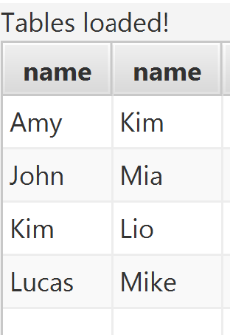

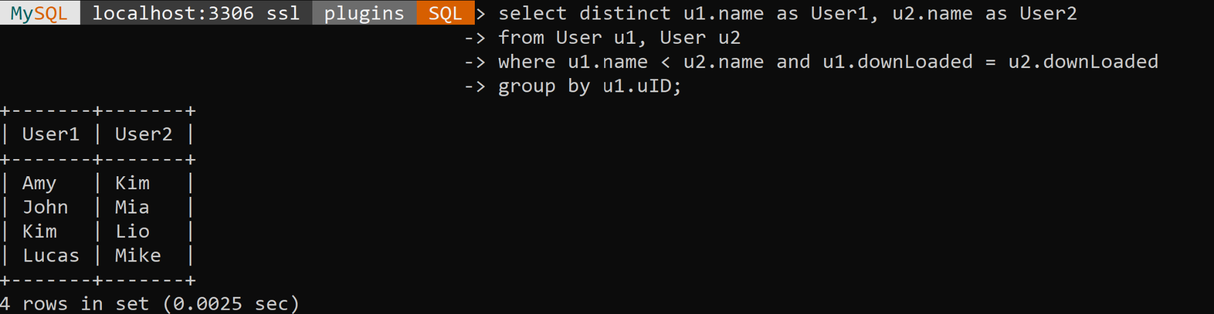

//select 8 find developers made only one type of plugins and not the other and the total the //plugins that developer made

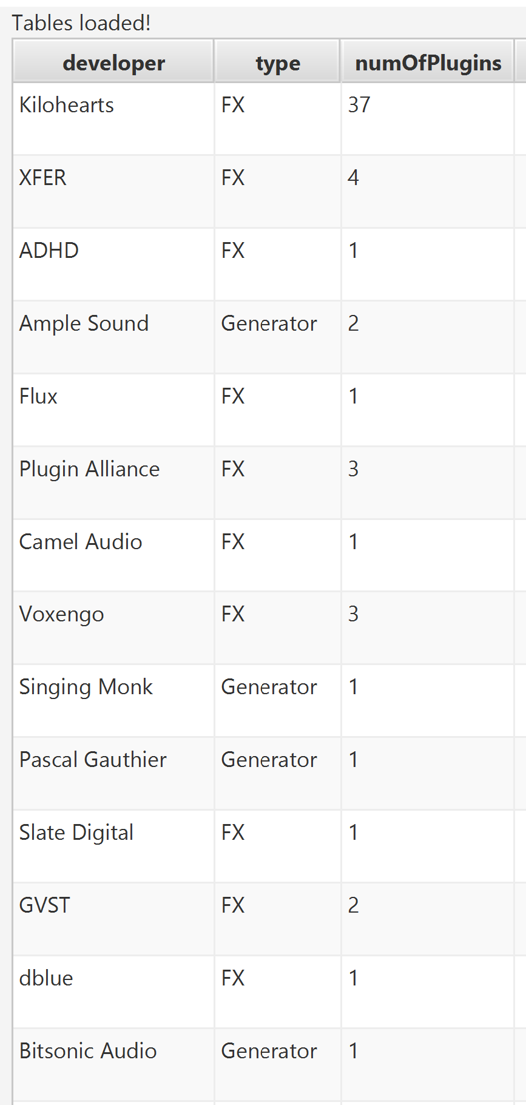

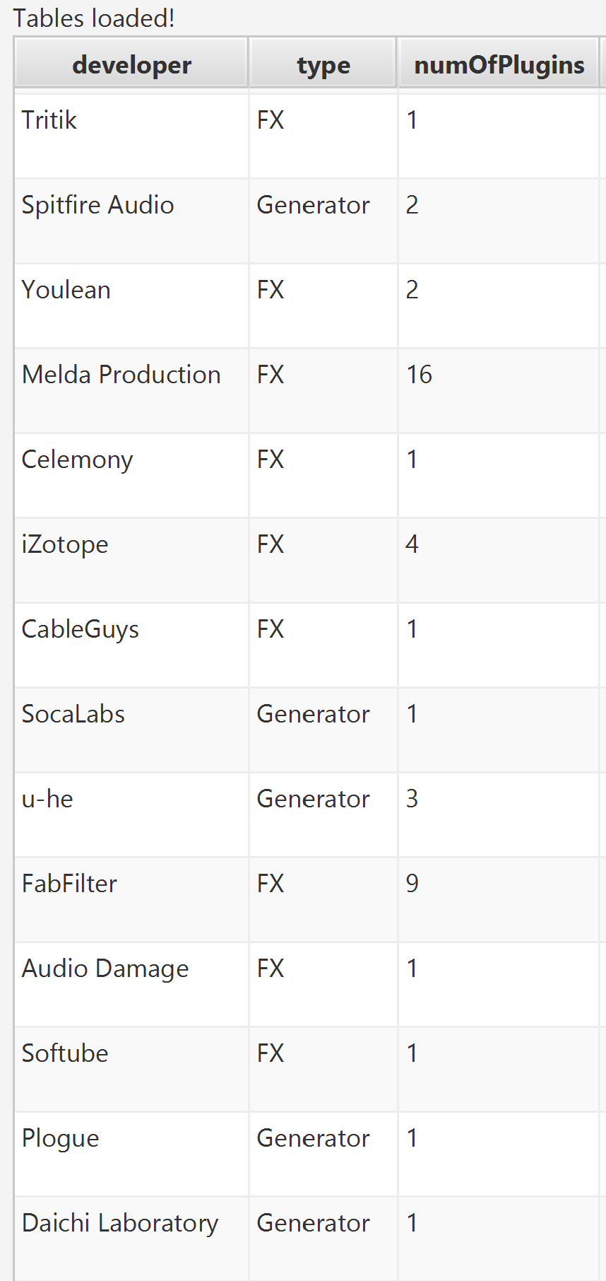

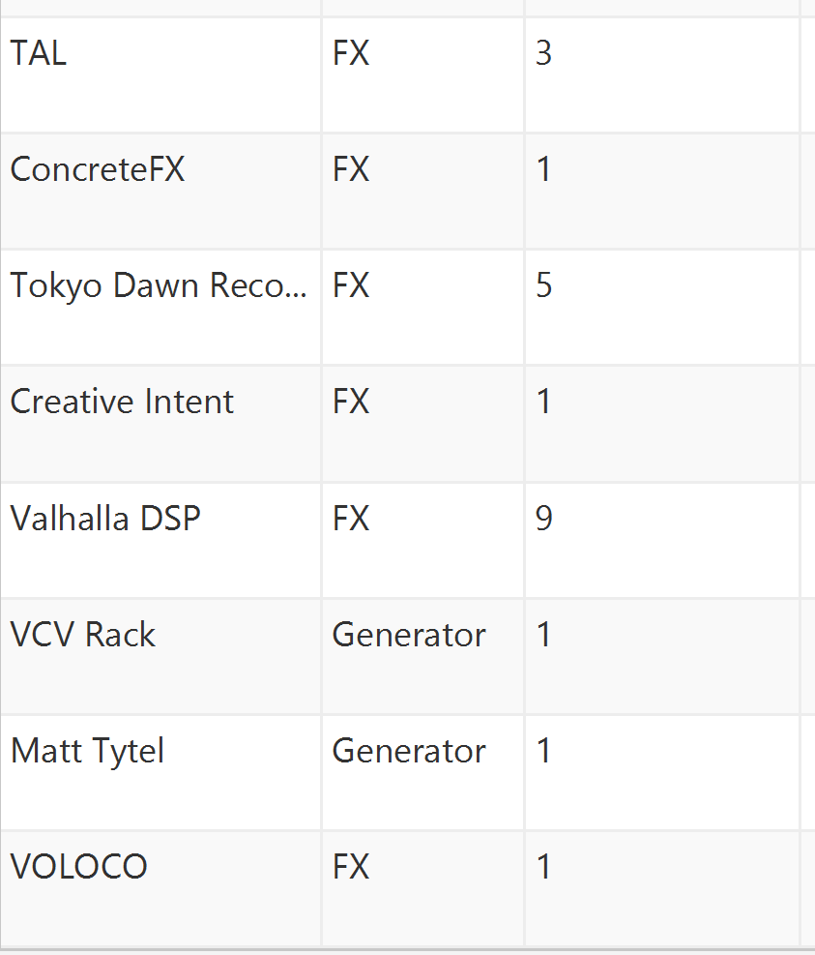

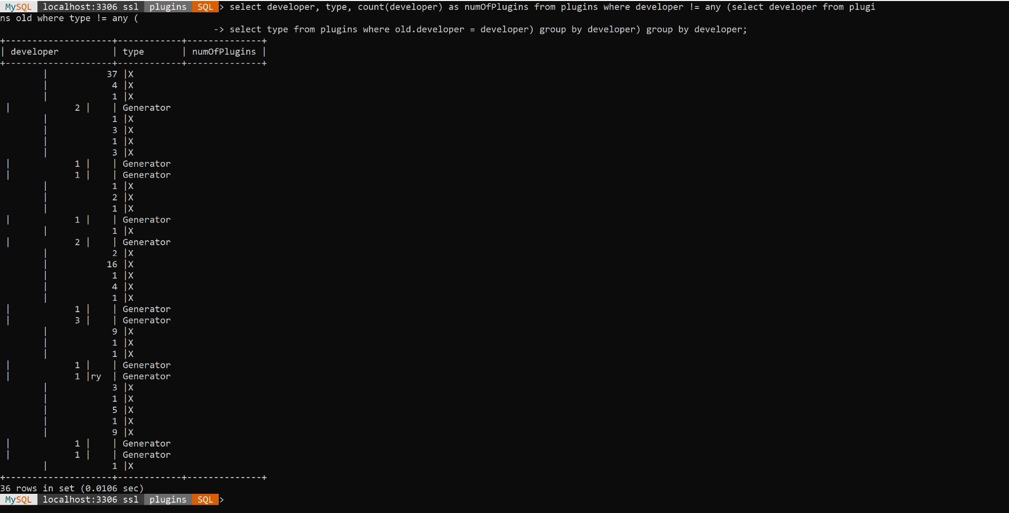

// select 9 : select user whose download is not free but has license

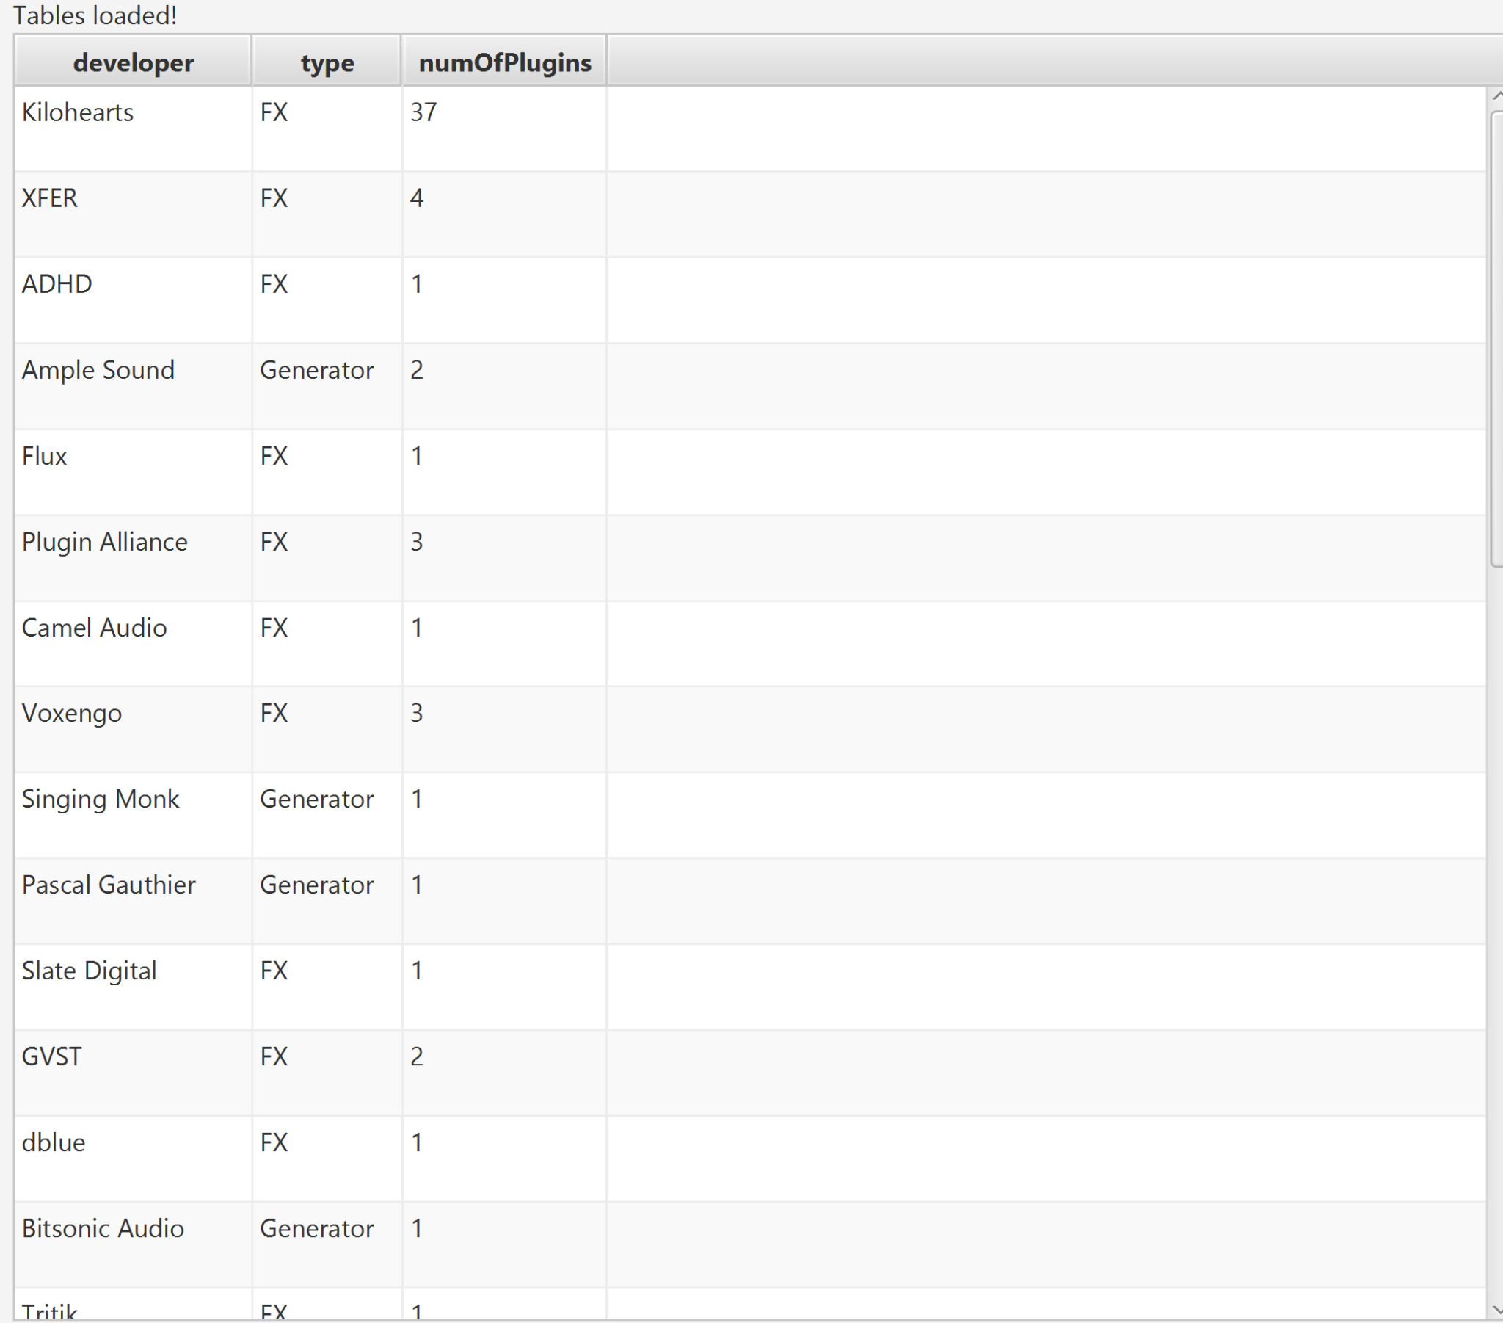

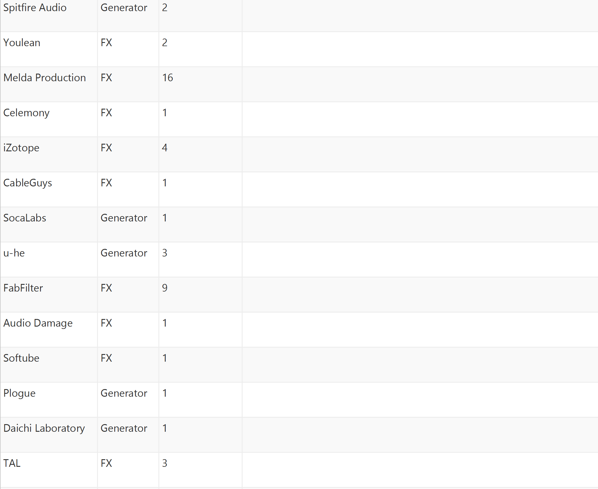

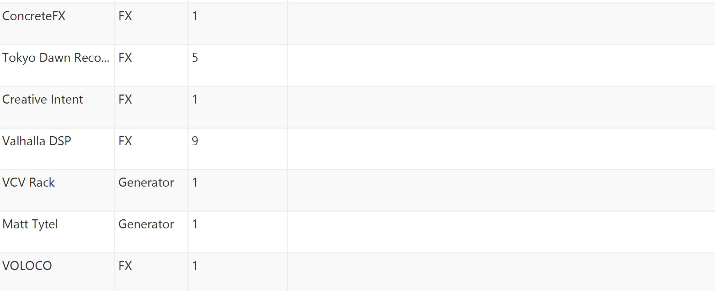

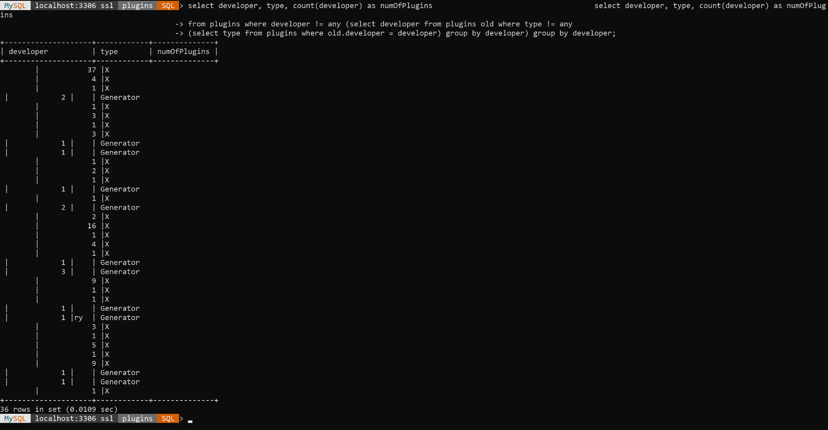

// update 1: update the plugin ‘Delay Lama’ with the current time.

Before update:

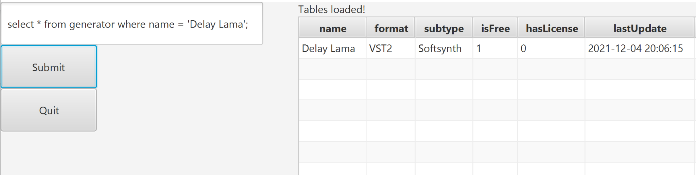

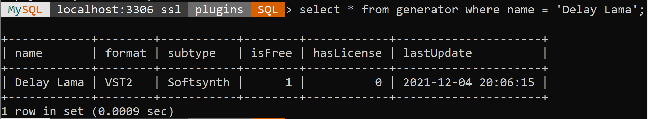

After update:

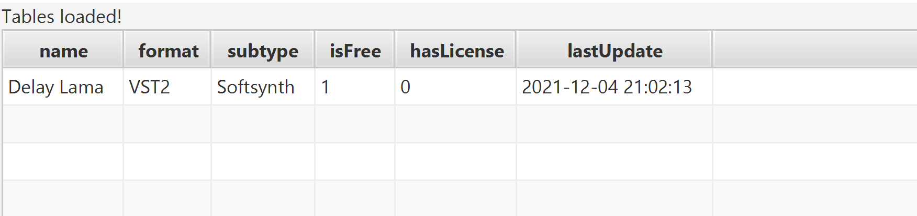

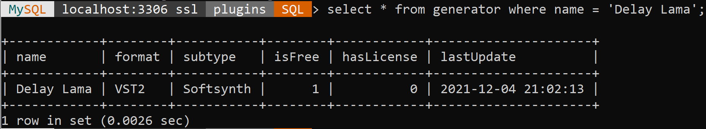

// update 2 : update generator by inverting the isFree variable for plugins with the subtype ‘ROMpler’

Before update:

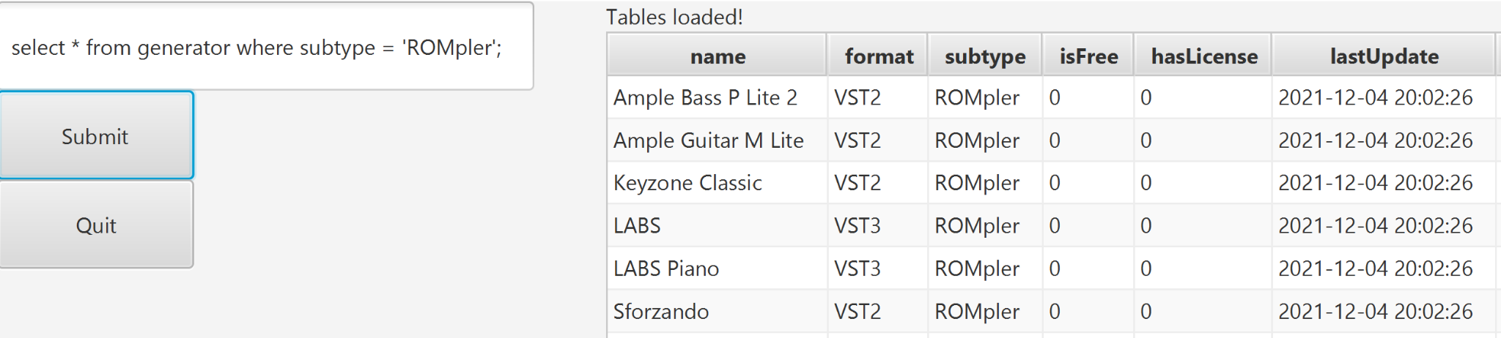

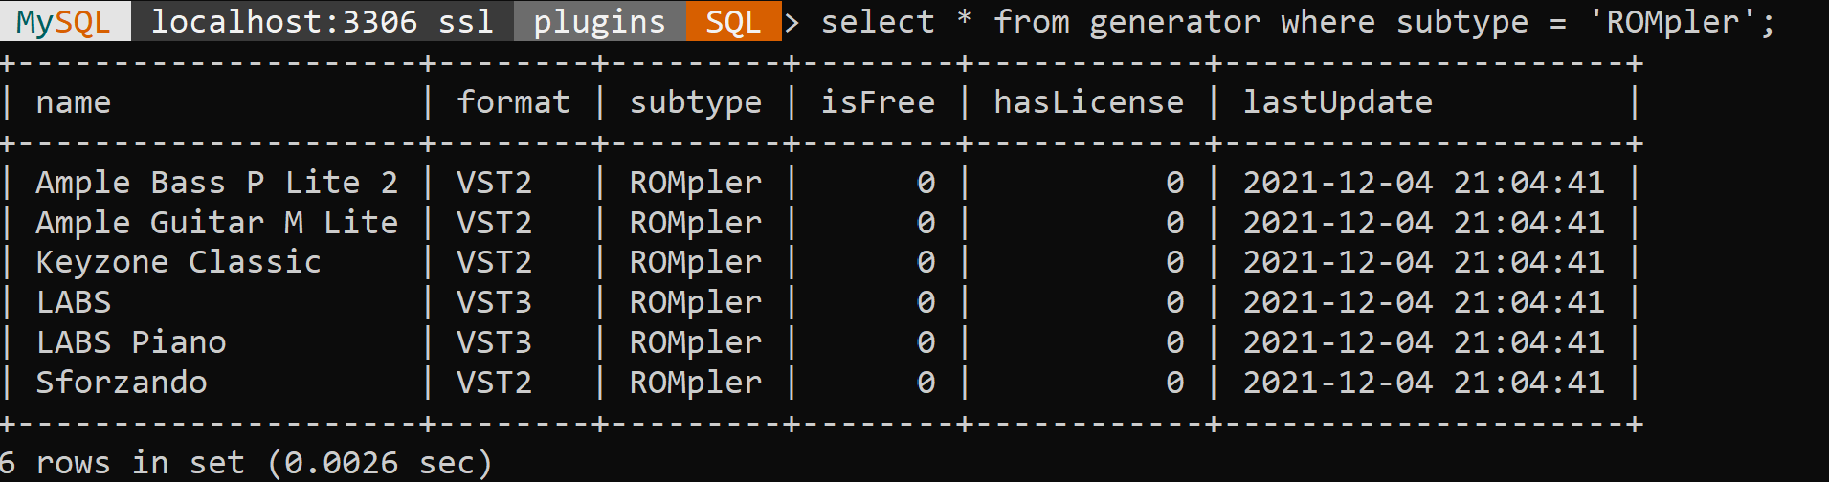

After update:

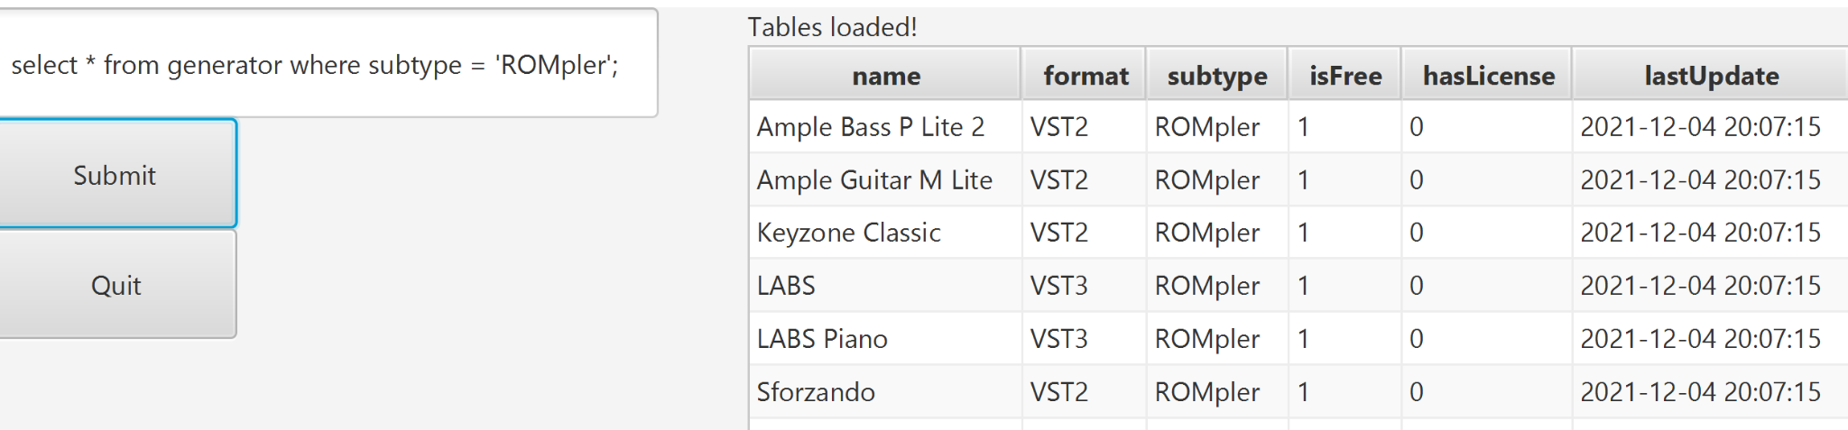

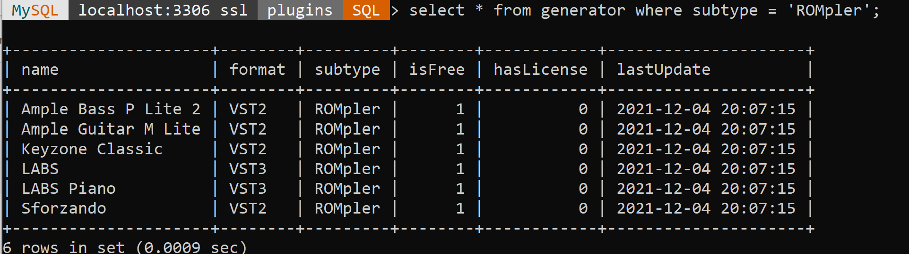

// delete 1 : work with trigger 2

/// delete the uid =7, and plugin = ‘Haas’ and downloadDate=’2021-09-26’ will delete the record // from the downloaded table as well as update the user table for the downloaded times for uid 7

Before delete:

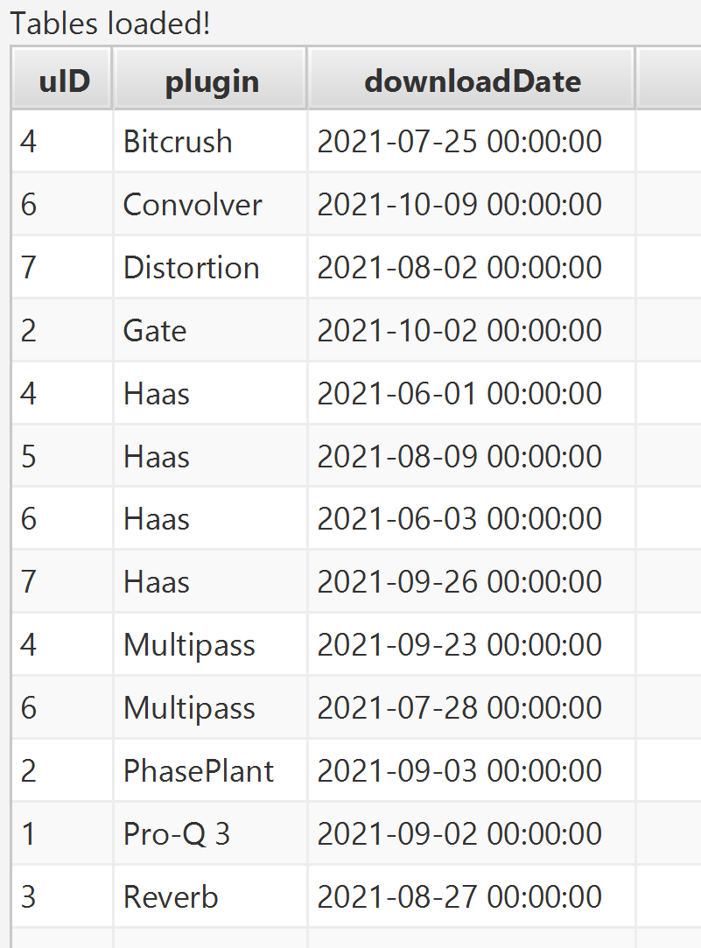

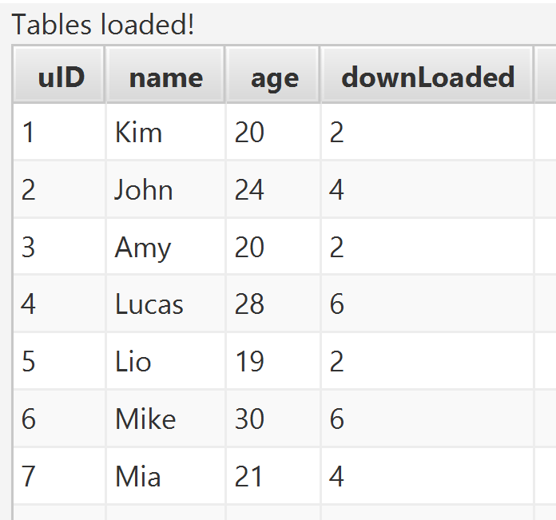

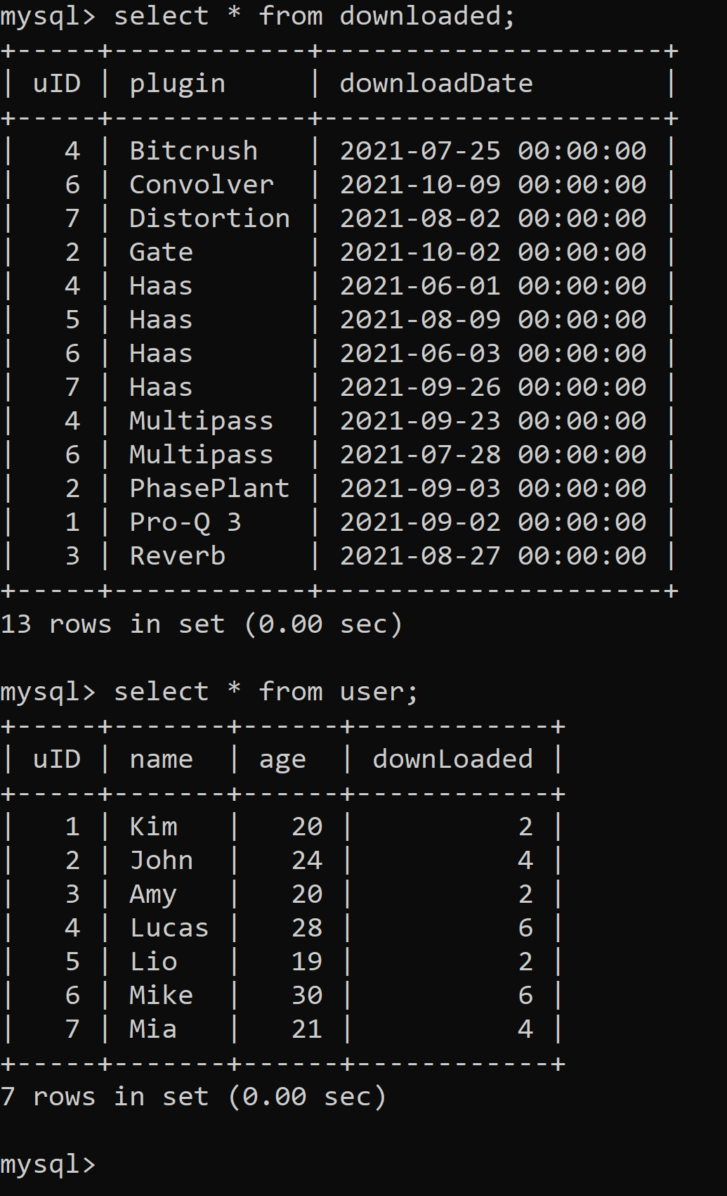

After delete:

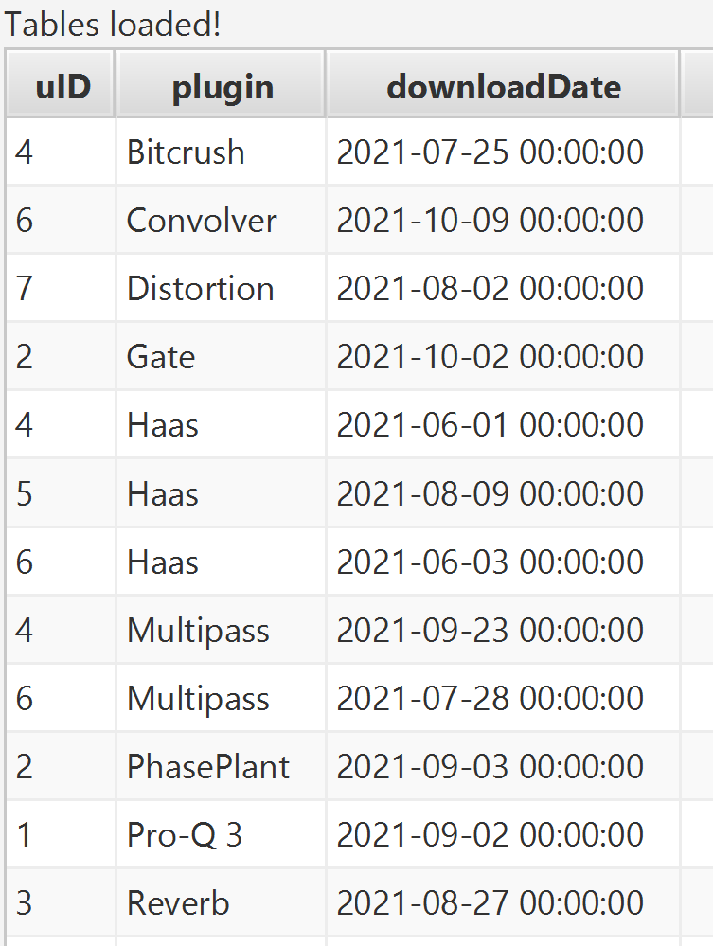

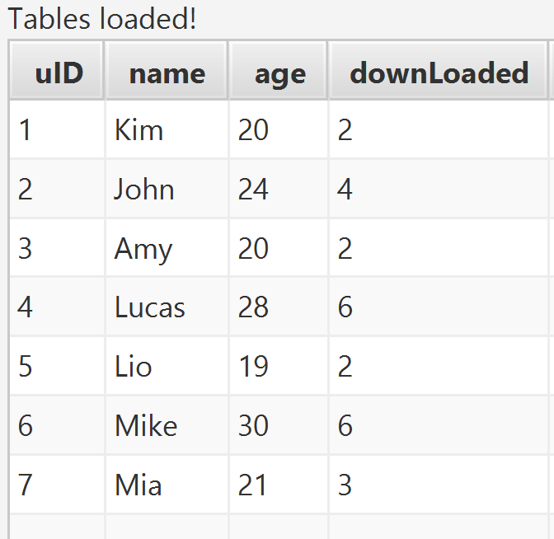

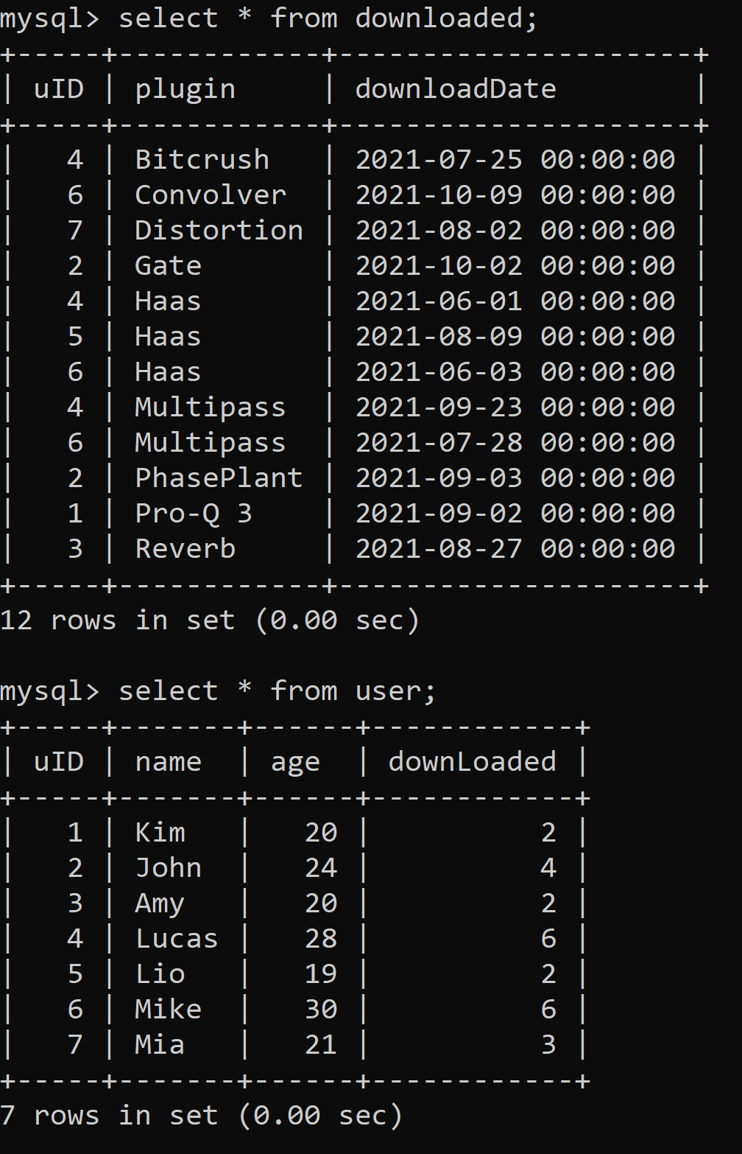

Note: deleting from downloaded affects user through trigger

// delete 2 // expiration after 4 months

//delete plugins that have not been updated in 4 months

Before delete:

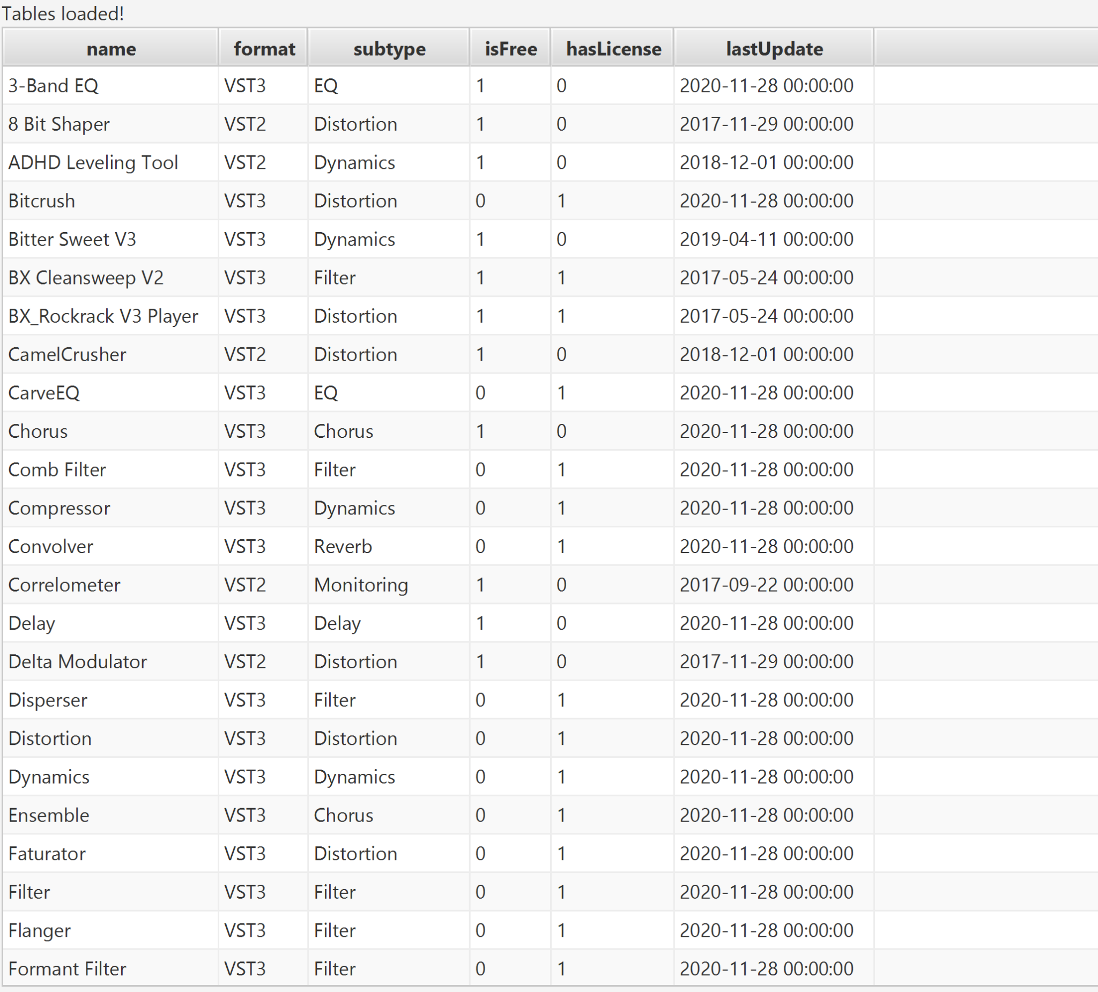

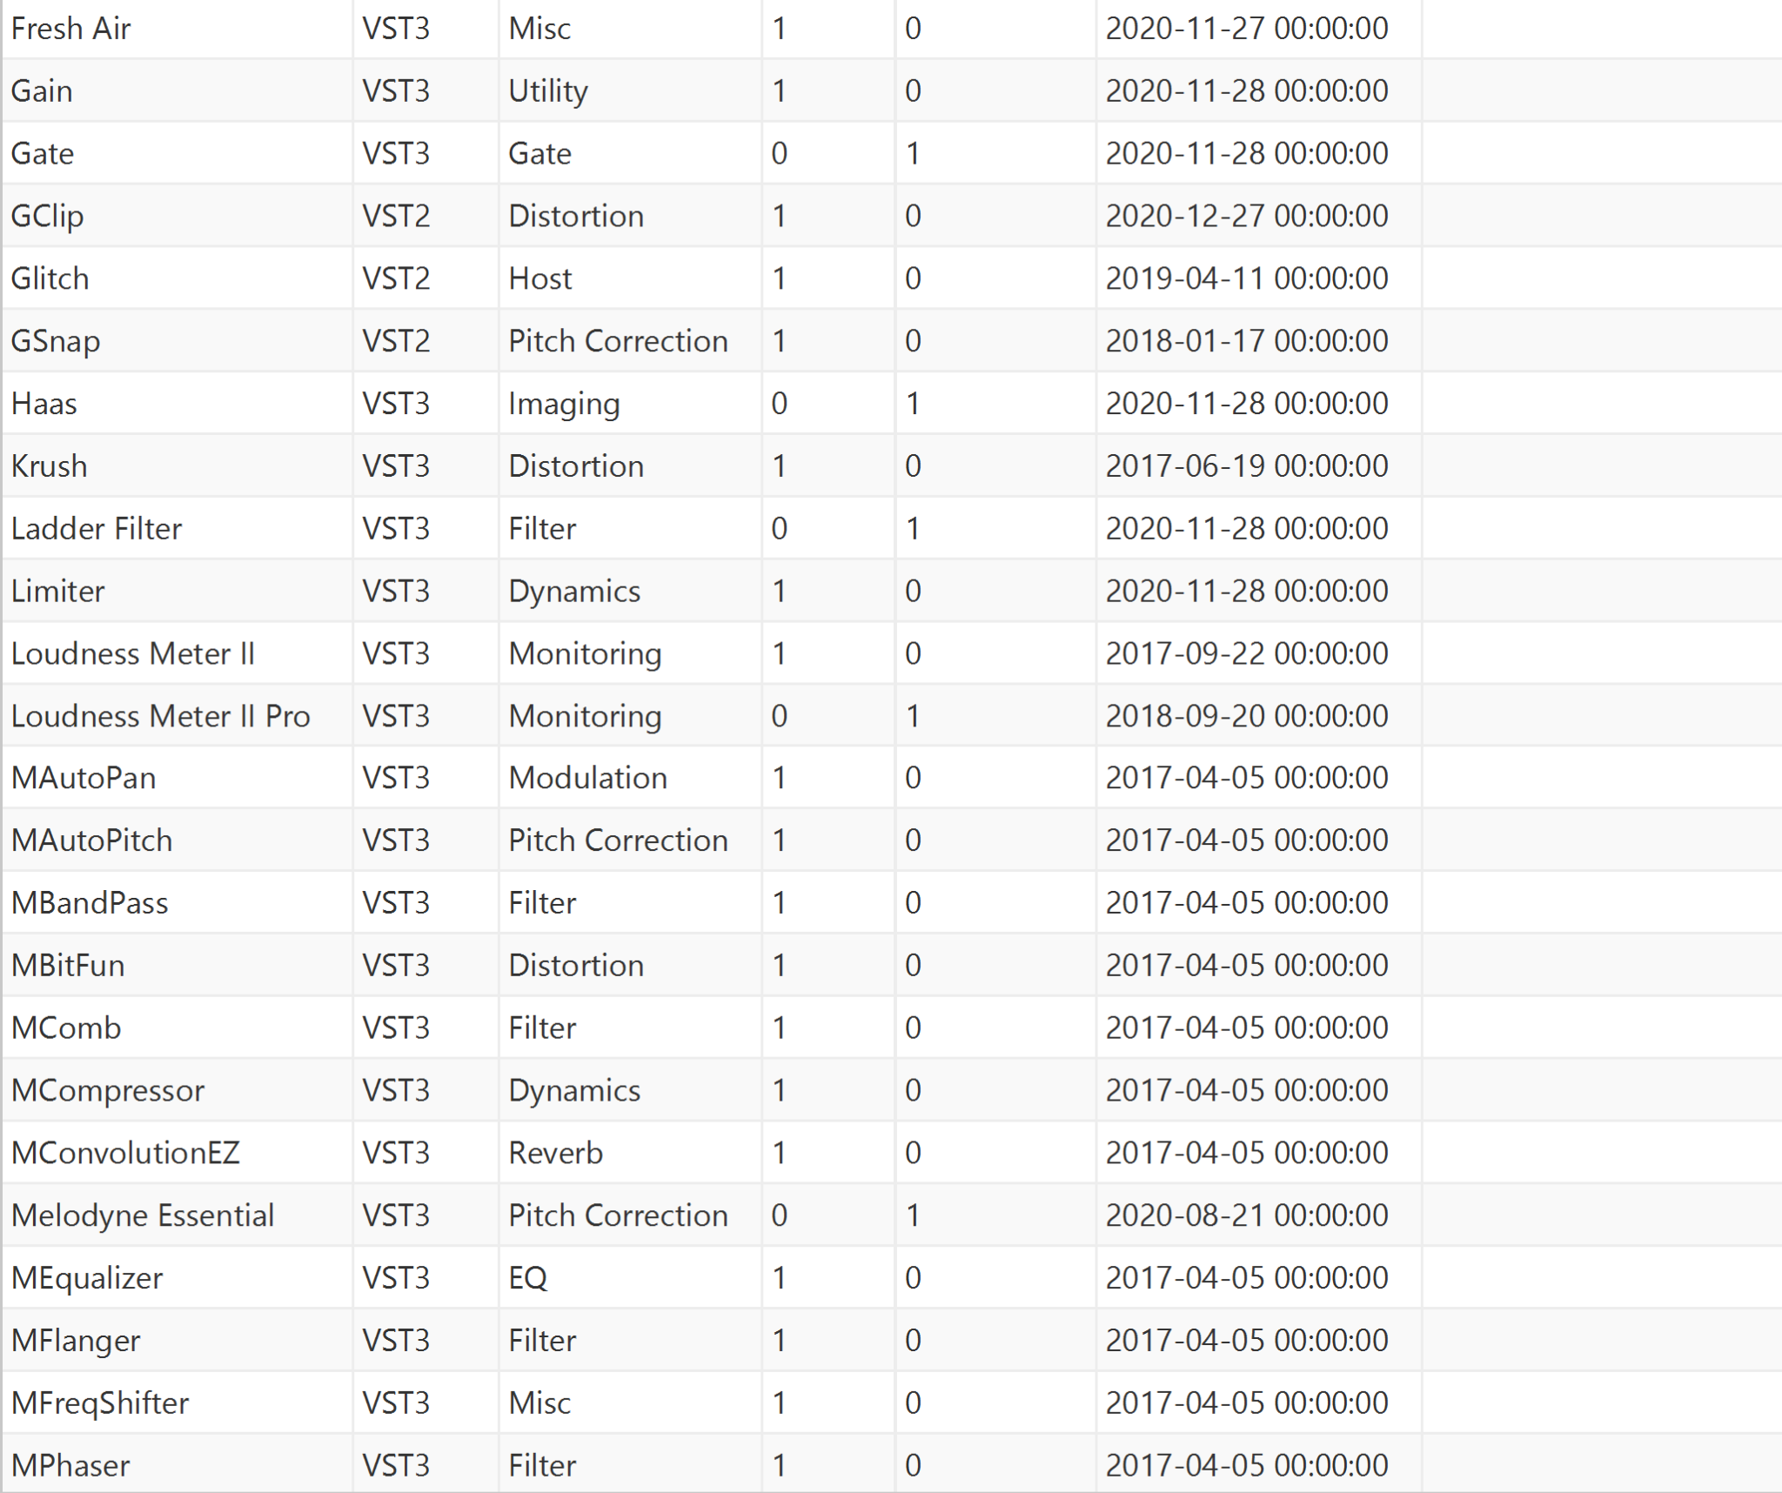

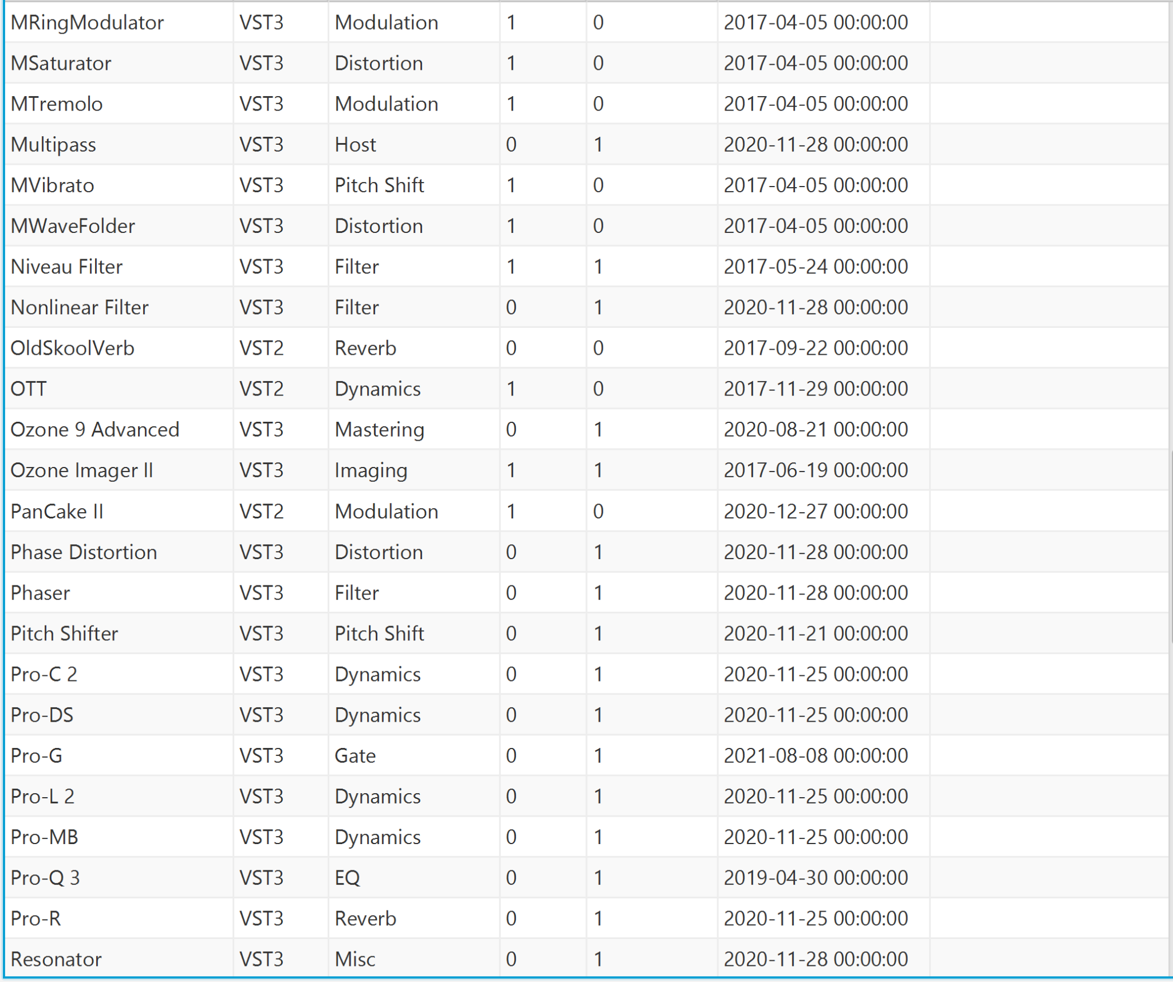

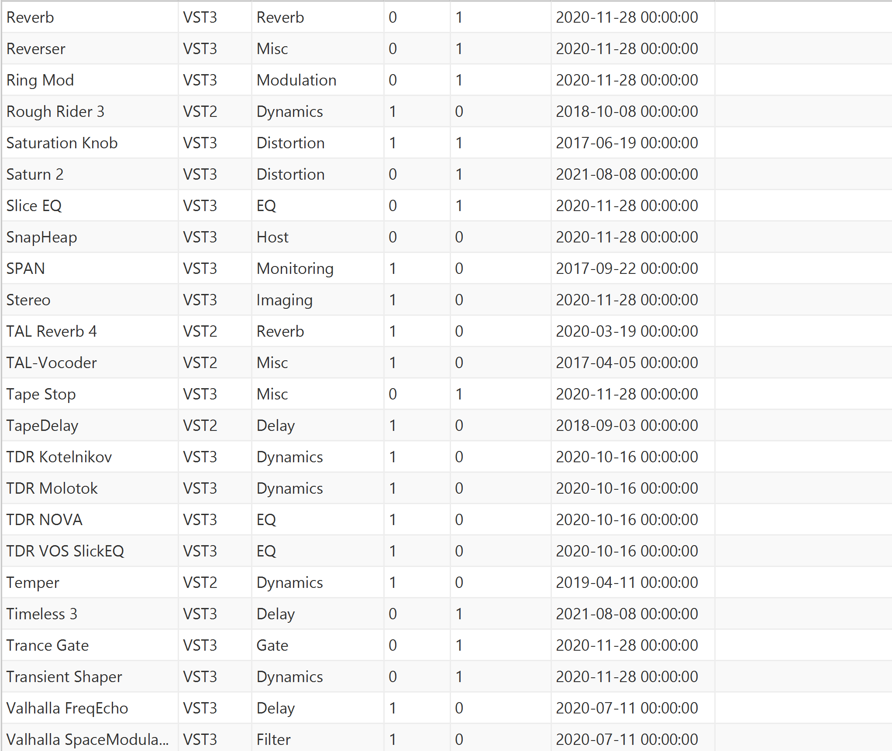

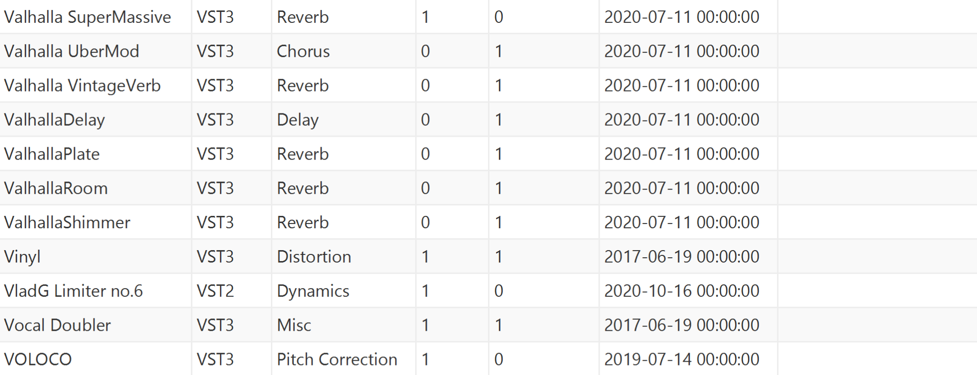







After delete:

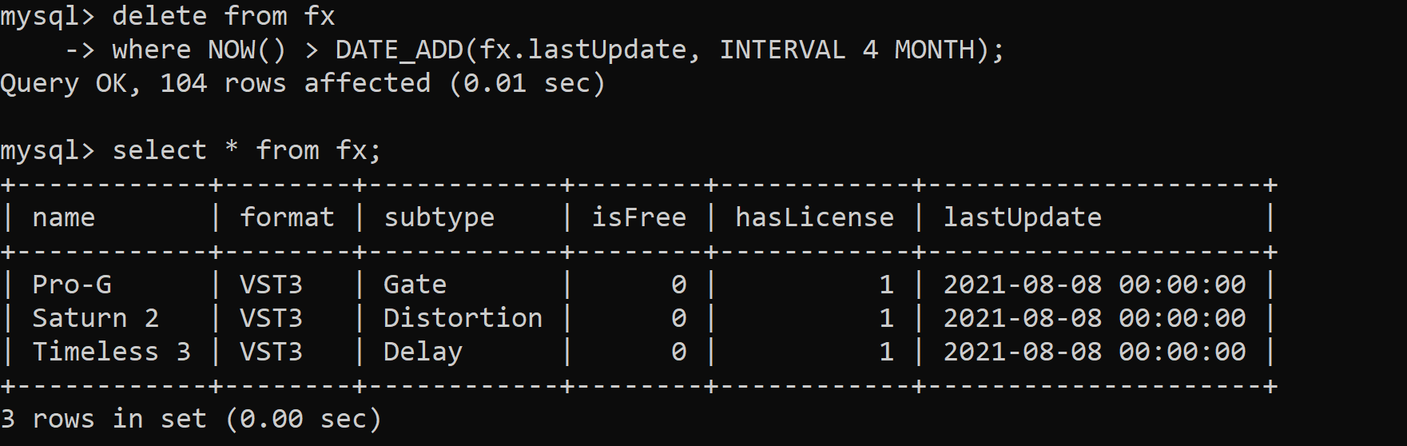

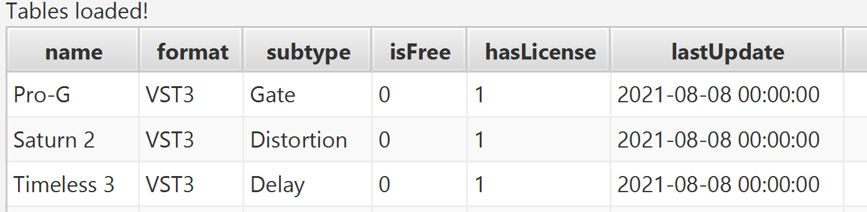

// insert 1: work with trigger 1

// for insert into downloaded table where user download new plugins at current time

insert into downloaded values(1, 'Haas', now());

Before insert:

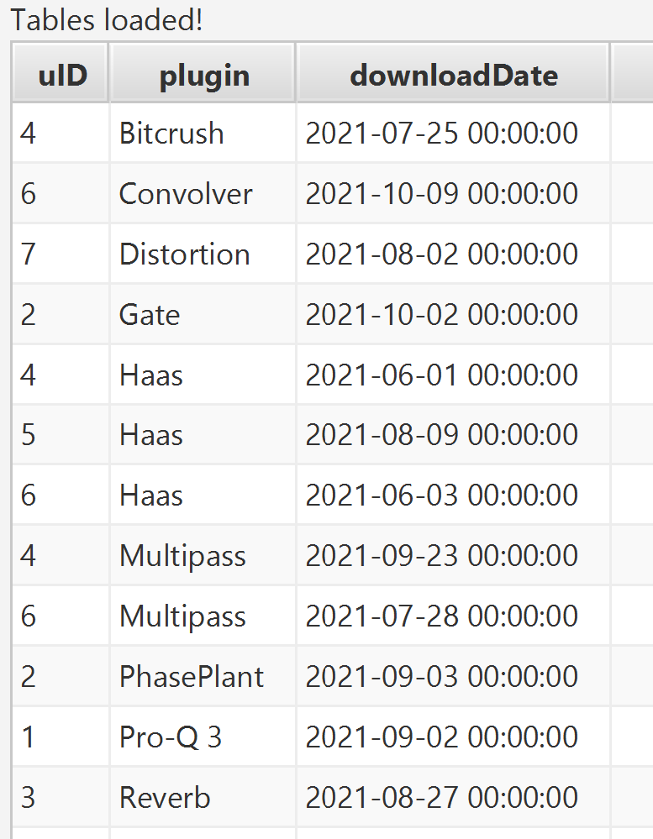

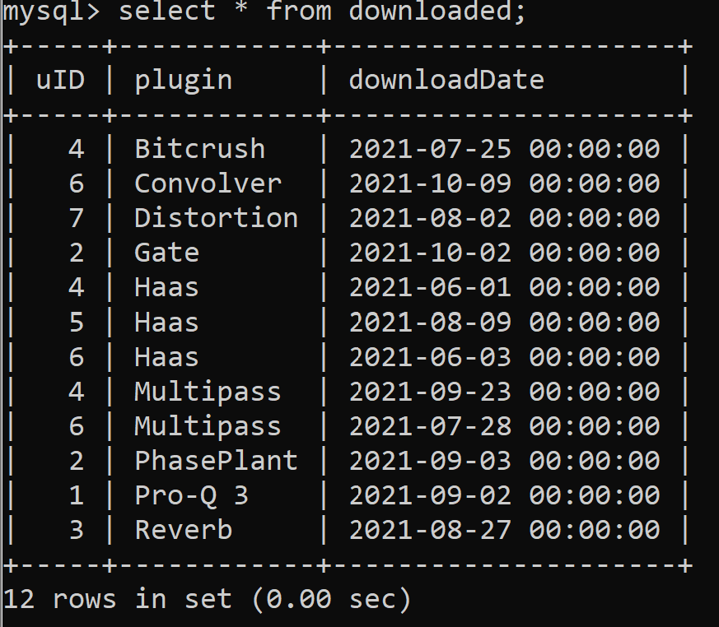

After insert:

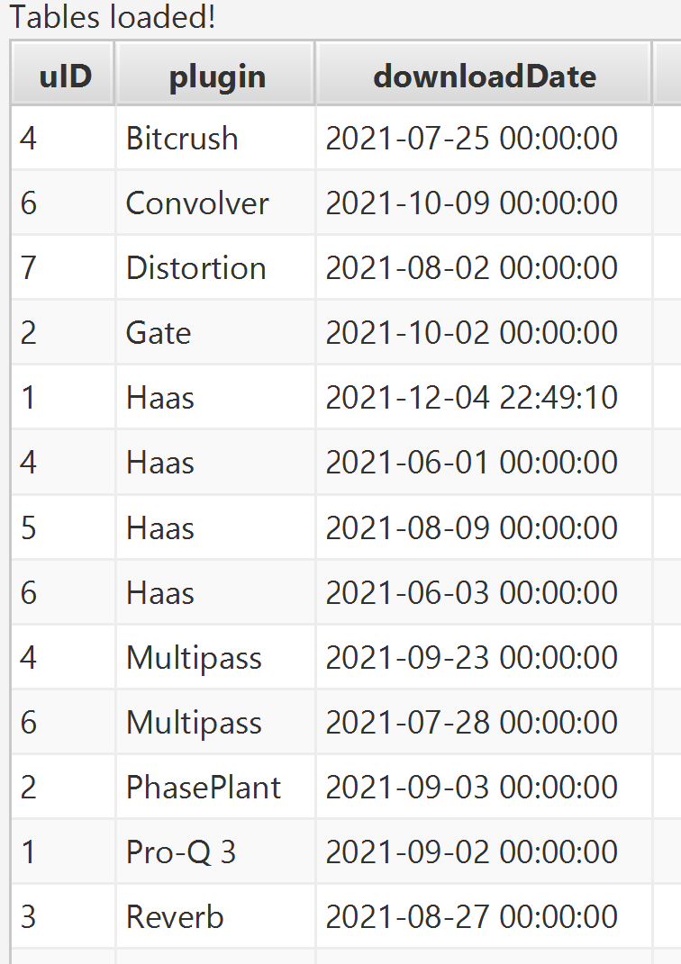

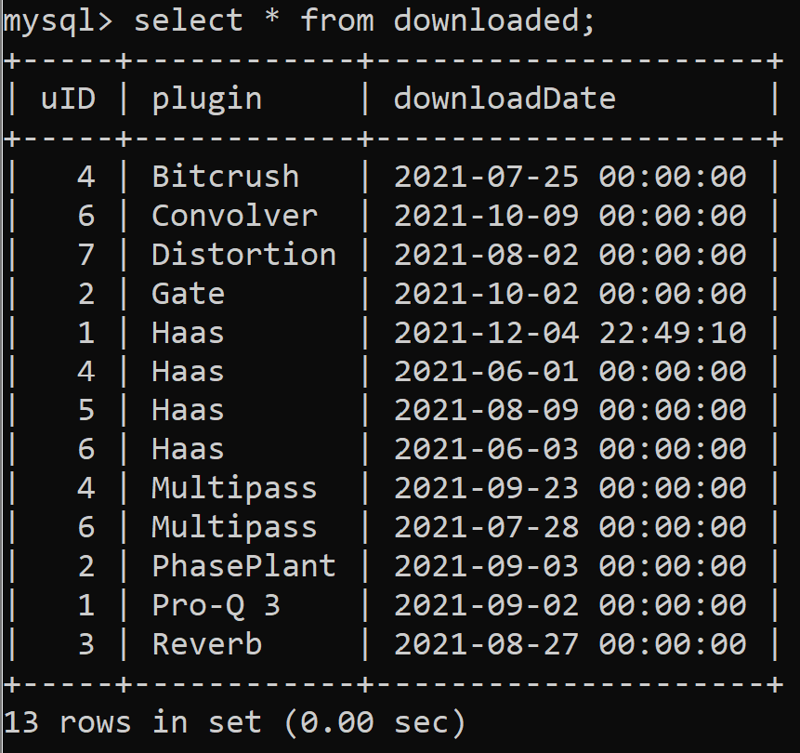

// insert 2: insert a new user

Before insert:

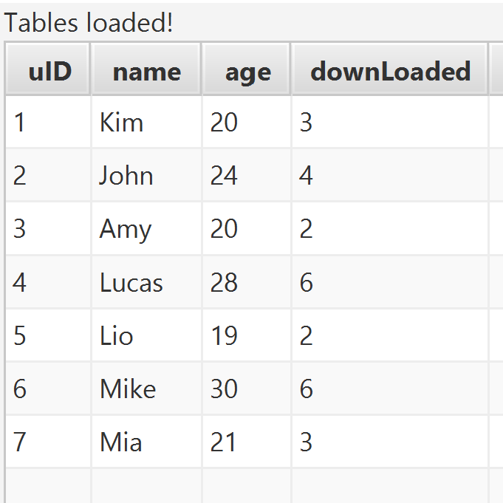

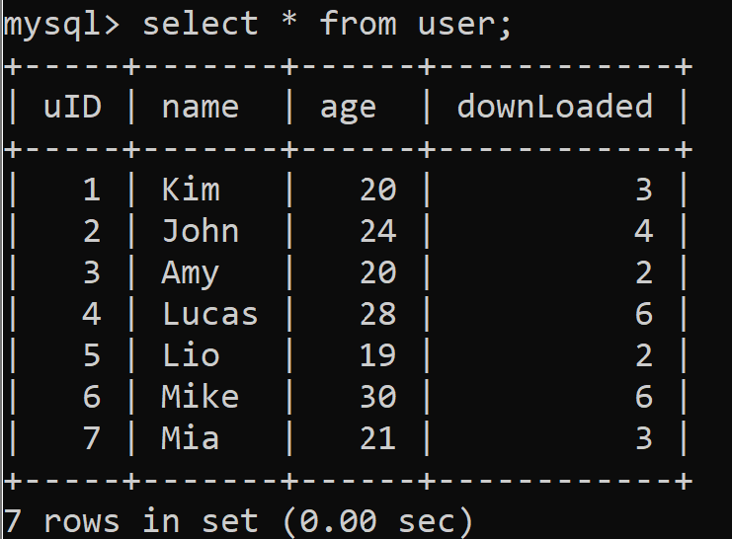

After insert:

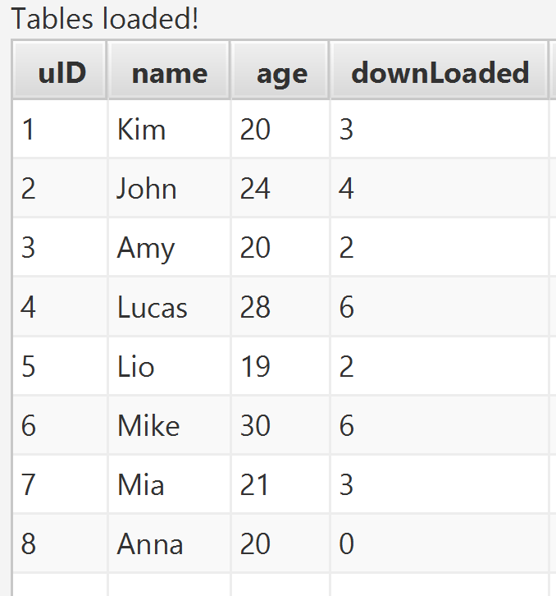

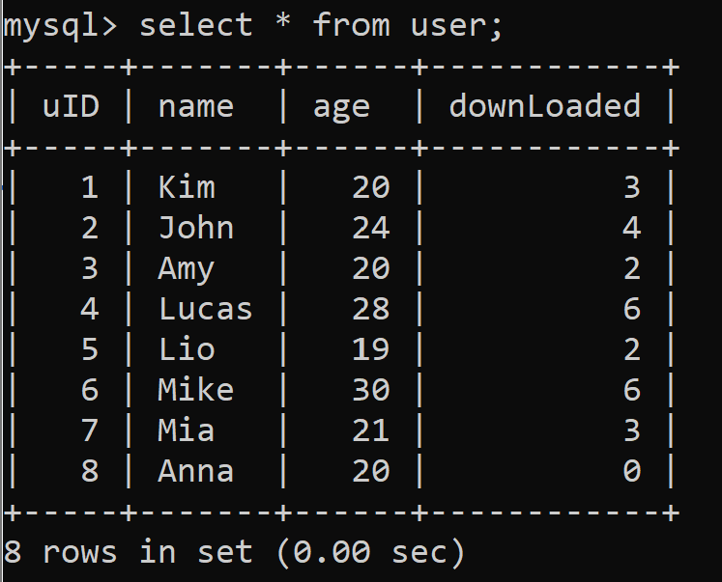

Note: automatic insertion of uID that is properly incremented with adding a new user

key constraint for User table

insert into user values(1, "jason", 20, 0);

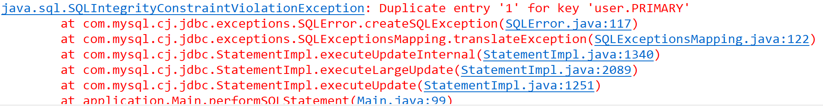

key constraint for Downloaded table

insert into downloaded values(2, "Gate", "2021-10-02");

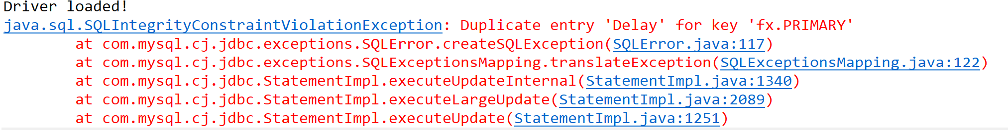

key constraint for plugins table

insert into plugins values("Chorus", "Slate Digital", "Generator");

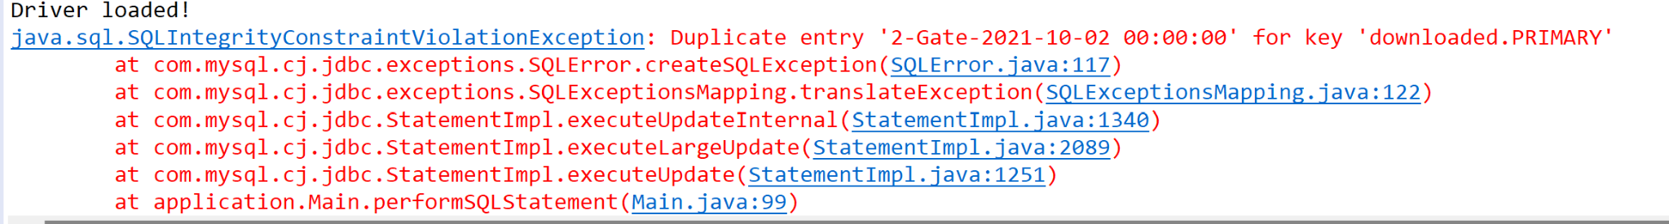

Foreign key constraint for Downloaded table update plugin

update downloaded set plugin = "Pro" where plugin = "Haas";

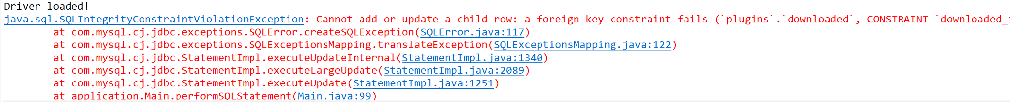

Archive:

Before archiving:

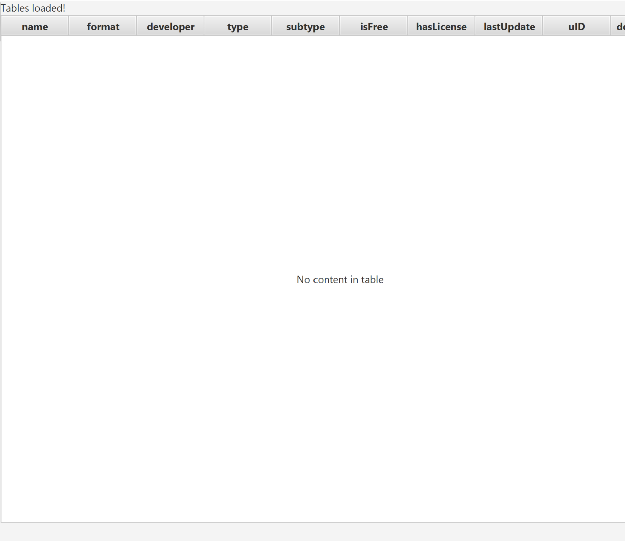

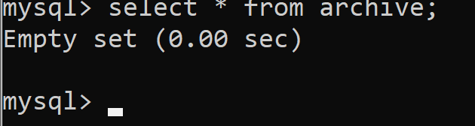

After archiving:

